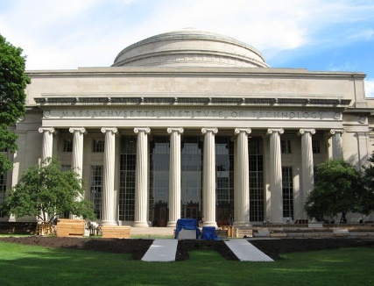
RMW16

The 16th Workshop on Reactive Metal Processing
March 24 (Fri.) – 25 (Sat.), 2023 @ MIT
(After TMS 2023, March 19 (Sun.) – 23 (Thu.), 2023 @ San Diego, California)
Organizers:
Donald R. Sadoway, Massachusetts Institute of Technology
Toru H. Okabe, Institute of Industrial Science (IIS),
The University of Tokyo
Antoine Allanore, Massachusetts Institute of Technology
Shunsuke Yagi, IIS, The University of Tokyo

Program Coordinators:
Takanari Ouchi, IIS, The University of Tokyo
Gen Kamimura, IIS, The University of Tokyo
Isaac Oda-Bayliss, IIS, The University of Tokyo
Jonathan Paras, Massachusetts Institute of Technology

Sponsors
-The Rare Metal Research Workshop, one of the Special Research Group
organized by the Foundation for the Promotion of Industrial Science
(RC-40: directed by Prof. T. H. Okabe)
-Donation to The University of Tokyo New York Office
by Dowa Metals & Mining Co., Ltd., Mitsubishi Materials Corporation,
Sumitomo Metal Mining Co., Ltd., and Tanaka Kikinzoku Kogyo K.K..
- Grant-in-Aid for Scientific Research (S) by JSPS (Project No. 19H05623)
-Research Center for Sustainable Material Energy Integration (RCSMEI)
-The Strategic Partnerships Project of the Top Global University Project by
The University of Tokyo
-Institute of Industrial Science, The University of Tokyo (IIS UTokyo SYMPOSIUM No.113)
http://www.okabe.iis.u-tokyo.ac.jp/core-to-core/rmw
The 16th Workshop on Reactive Metal Processing
(IIS UTokyo SYMPOSIUM No.113)
March 24 (Fri.) – March 25 (Sat.), 2023, MIT, Cambridge, MA

Time:
- 1st day: on March 24 (10:00 – 17:00 and Banquet at 18:30)
- 2nd day: on March 25 (10:00 – 14:00)
Refreshments will be served around 9:00 AM on both days.
Venue:
- Haus Allen Room (MIT)
- Le Méridien Cambridge
Registration Fee:
$200 / person
NOTICE: Please prepare to pay the registration fee in cash!
Organizers:
Prof. Donald R. Sadoway, Massachusetts Institute of Technology
Prof. Toru H. Okabe, IIS, The University of Tokyo
Prof. Antoine Allanore, Massachusetts Institute of Technology
Prof. Shunsuke Yagi, IIS, The University of Tokyo
Program Coordinators:
Takanari Ouchi, IIS, The University of Tokyo
Gen Kamimura, IIS, The University of Tokyo
Isaac Oda-Bayliss, IIS, The University of Tokyo
Jonathan Paras, Massachusetts Institute of Technology
Sponsors:
-The Rare Metal Research Workshop, one of the Special Research Group
organized by the Foundation for the Promotion of Industrial Science
(RC-40: directed by Prof. T. H. Okabe)
-Donation to The University of Tokyo New York Office
by Dowa Metals & Mining Co., Ltd., Mitsubishi Materials Corporation,
Sumitomo Metal Mining Co., Ltd., and Tanaka Kikinzoku Kogyo K.K..
- Grant-in-Aid for Scientific Research (S) by JSPS (Project No. 19H05623)
-Research Center for Sustainable Material Energy Integration (RCSMEI)
-The Strategic Partnerships Project of the Top Global University Project by
The University of Tokyo
-Institute of Industrial Science, The University of Tokyo
(IIS UTokyo SYMPOSIUM No.113)

Contact:
Isaac Oda-Bayliss, IIS, The University of Tokyo
E-mail: aisaku-oda@g.ecc.u-tokyo.ac.jp
Workshop Program
Day 1
Morning, March 24 (Friday), 2023 @ Haus Allen Room (MIT)
9:00 – 10:00 Coffee & Breakfast Service
10:00 – 10:10 Opening Remarks
Prof. Antoine Allanore
Massachusetts Institute of Technology

Session Chair: Prof. Antoine Allanore
10:10 – 10:40 Aluminium-sulfur Battery for Long-duration Stationary Power Delivery
Donald R. Sadoway
Massachusetts Institute of Technology

10:40 – 11:00 Break

Session Chair: Dr. Takanari Ouchi
11:00 – 11:30 Recent Development of Positive Electrode Active Materials for Magnesium Rechargeable Batteries
Shunsuke Yagi
IIS, The University of Tokyo
11:30 – 12:00 Sulfidation Chemistry for Materials Processing
Casper Stinn
Massachusetts Institute of Technology

12:00 – 13:00 Lunch

Session Chair: Prof. Geir Martin Haarberg
13:00 – 13:30 Anodic Electrochemical Deposition and Its Application
Takanari Ouchi
The University of Tokyo
13:30 – 14:00 Aluminum Production with Oxygen Evolving Inert Anodes: Some Recent Developments
Guðrún Sævarsdóttir
Reykjavik University, NTNU

14:00 – 14:20 Photo & Break

Session Chair: Dr. Gen Kamimura
14:20 – 15:20 3-min Short Presentation by Poster Presenters
15:20 – 16:20 Poster Session at the Haus Room and Allen Room at Building 36

18:00 – Reception @ Le Méridien Cambridge
18:30 – Banquet @ Le Méridien Cambridge
Day 2
Morning, March 25 (Saturday), 2023 @ Haus Allen Room (MIT)
9:00 – 10:00 Coffee & Breakfast Service
10:00 – 10:10 Opening Remarks
Prof. Shunsuke Yagi IIS, The University of Tokyo

Session Chair: Prof. Shunsuke Yagi
10:10 – 10:40 A Magnesium Clean Energy Ecosystem Vision
Adam C. Powell IV
Worcester Polytechnic Institute

10:40 – 11:00 Break

Session Chair: Prof. Adam C. Powell IV
11:00 – 11:30 Proposal for Mg Production in Japan
Toshihide Takenaka
Kansai University
11:30 – 12:00 Electrowinning of Aluminium and Carbon Footprint
Geir Martin Haarberg
NTNU

12:00 – 12:10 Information for the Next RMW
Prof. Toru H. Okabe, IIS, The University of Tokyo
12:10 – 12:20 Closing Remarks
Prof. Donald R. Sadoway, Massachusetts Institute of Technology

12:20 – 13:30 Lunch

13:30 – Laboratory Tour (for applicants)

List of Poster Presentations
1. Investigation of α-MnO₂ cathode in Magnesium Rechargeable Batteries
Isaac Oda-Bayliss¹,
¹The University of Tokyo
2. Metal Leaching and Multiple Effect Distillation for Neodymium Magnet Recycling
Chinenye Chinwego, Emmanuel Offei Opoku¹,
¹Worcester Polytechnic Institute
3. Study of Diaphragm Material used in Na-Zn Liquid Metal Battery for Stationary Energy Storage
Cathrine Kyung Won Solem¹,
¹SINTEF
4. Recovery of precious metals from scraps using electrochemical anodic deposition in molten salt electrolyte
Yuka Kujiraoka¹,
¹The University of Tokyo
5. Electrochemical recovery of Au and Ag from ore deposits using innovative Deep Eutectic Solvent ionic liquids
Gøril Jahrsengene¹,
¹SINTEF
6. Electrochemical Reduction of Iron Oxide for the Valorizing the Iron Fuel Cycle
Akmal Irfan Majid¹,
¹Eindhoven University of Technology
7. Optimization of Ni Electrodeposition for Alkaline Water Electrolyzers
Yukihiro Takahashi¹,
¹Norwegian University of Science and Technology (NTNU)
8. Recent technological developments for liquid displacement battery
Kashif Mushtaq¹,
¹LEPABE, University of Porto, Portugal
9. Fundamental study on recycling process for zinc with alkaline solution
Akihiro Kishimoto¹,
¹Kyoto University
10. Anodic Behavior of MoSi₂ Containing Nb in MgCl₂-NaCl-CaCl₂ Molten Salt
Shunsuke Irie¹,
¹Kansai University Graduate School
List of Poster Presentations
11. Liquid metal Si deposition in molten CaCl₂ with the different molar ratio of CaO to SiO₂
Kosei Takahashi¹,
¹Graduate School of Science and Engineering, Kansai University, Japan
12. Effect of impurities on Mg Metal Deposition in Molten Salt Electrolysis
Tatsuya Sasaki¹,
¹Kansai University Graduate School
13. Advances in Magnesium Primary Production by Reactive Cathode Molten Salt Electrolysis with G-METS Distillation
Zujian Tang, Daniel McArthur Sehar¹,
¹Worcester Polytechnic Institute
14. Numerical Modeling of Silicon Electrodeposition
Aditya Moudgal¹,
¹Worcester Polytechnic Institute

History of RMW
2006 The 1st Workshop on Reactive Metal Processing (RMW1)
March 17 (Fri.) - March 19 (Sat.), Cambridge, MIT
2006 The 2nd Workshop on Reactive Metal Processing (RMW2)
November 16 (Thurs.) - November 17 (Fri.), Tokyo, The University of Tokyo
2007 The 3rd Workshop on Reactive Metal Processing (RMW3)
March 2 (Fri.) - March 3 (Sat.), Cambridge, MIT
2008 The 4th Workshop on Reactive Metal Processing (RMW4)
March 14 (Fri.) - March 15 (Sat.), Cambridge, MIT
2010 The 5th Workshop on Reactive Metal Processing (RMW5)
February 18 (Thurs.) - February 19 (Fri.), Seattle, Red Lion Hotel on 5th Avenue
2011 The 6th Workshop on Reactive Metal Processing (RMW6)
March 4 (Fri.) - March 5 (Sat.), Pasadena, Caltech
2012 The 7th Workshop on Reactive Metal Processing (RMW7)
March 16 (Fri.) - March 17 (Sat.), Cambridge, MIT
2013 The 8th Workshop on Reactive Metal Processing (RMW8)
March 8 (Fri.) - March 9 (Sat.), Cambridge, MIT
2014 The 9th Workshop on Reactive Metal Processing (RMW9)
February 21 (Fri.) - February 22 (Sat.), Pasadena, Caltech
2015 The 10th Workshop on Reactive Metal Processing (RMW10)
March 20 (Fri.) - March 21 (Sat.), Cambridge, MIT
2016 The 11th Workshop on Reactive Metal Processing (RMW11)
February 19 (Fri.) - February 20 (Sat.), Cambridge, MIT
2017 The 12th Workshop on Reactive Metal Processing (RMW12)
March 3 (Fri.) - March 4 (Sat.), Cambridge, MIT
2018 The 13th Workshop on Reactive Metal Processing (RMW13)
March 16 (Fri.) - March 17 (Sat.), Cambridge, MIT
2019 The 14th Workshop on Reactive Metal Processing (RMW14)
March 15 (Fri.) - March 16 (Sat.), Cambridge, MIT
2020 The 15th Workshop on Reactive Metal Processing (RMW15)
February 28 (Fri.) - February 29 (Sat.), San Diego, UC San Diego
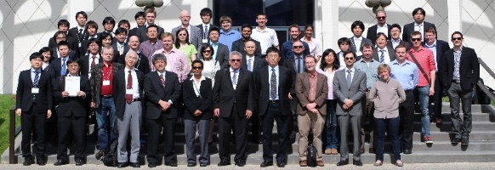
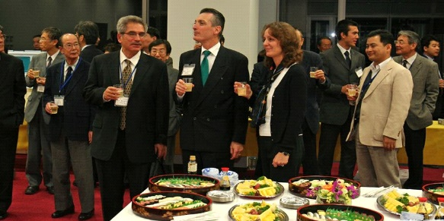
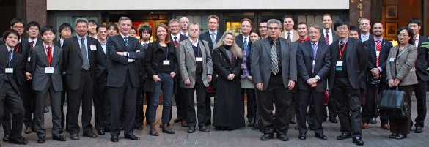
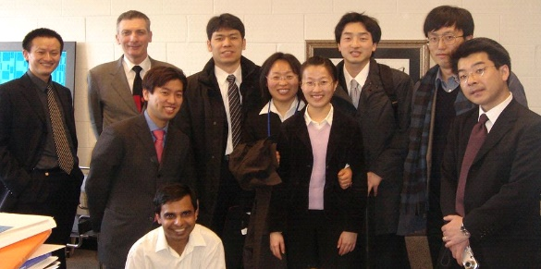
RMW2 in 2006 at IIS
RMW1 in 2006 at MIT
RMW9 in 2014 at CALTECH
RMW5 in 2010 at Seattle
RMW15 in 2020 at San Diego
List of Participants
Adam Powell | Associate Professor | Worcester Polytechnic Institute
Aditya Moudgal | Graduate Student | Worcester Polytechnic Institute
Akihiro Kishimoto | Assistant Professor | Kyoto University
Akmal Irfan Majid | PhD Student | Eindhoven University of Technology
Alex Grant | CEO | Magrathea
Antoine Allanore | Associate Professor | MIT
Ayaka Sakamoto | Administrative Staff | IIS, The University of Tokyo
Brandon Velasquez | PhD Student | Reykjavik University
Caspar Stinn | PhD Candidate | MIT
Cathrine KW Solem | Research Scientist | SINTEF
Charles Boury | PhD Student | MIT
Chinenye Chinwego | PhD Candidate | Worcester Polytechnic Institute
Daniel McArthur Sehar | PhD Student | Worcester Polytechnic Institute
Donald Sadoway | Chief Scientist | Sadoway Labs
Emmanuel Offei | Masters Student | Worcester Polytechnic Institute
Geir Martin Haarberg | Professor | NTNU
Gen Kamimura | Research Associate | IIS, The University of Tokyo
Gøril Jahrsengene | Research Scientist | SINTEF
Gudrun Saevarsdottir | Professor | Reykjavik University and NTNU
Isaac Oda-Bayliss | Masters Student | IIS, The University of Tokyo
Jacob Brown | CTO | Magrathea
Jumpei Matsumura | Joint Researcher | Japan Aviation Electronics Industry, Ltd. (IIS)
Kamaljeet Singh | PhD Student | Reykjavik University and NTNU
Kashif Mushtaq | Post-doc Researcher | LEPABE, University of Porto
Kosei Takahashi | Graduate Student | Kansai University Graduate School
Masatoshi Ueno | Managing Director | Komatsu
Ragnhild E. Aune | Professor | NTNU
Rochelle Zordich | Industry Advisor | WPI EMRG
Sai Krishna Padamata | Post-doc Researcher | Reykjavik University
Shinya Suzuki | Research Scientist | IIS, The University of Tokyo
Shunsuke Irie | Graduate Student | Kansai University Graduate School
Shunsuke Yagi | Associate Professor | IIS, The University of Tokyo
Takanari Ouchi | Lecturer | IIS, The University of Tokyo
Tatsuya Sasaki | Graduate Student | Kansai University Graduate School
List of Participants
Tomás Villalon Jr. | CTO, Co-Founder | Phoenix Tailings
Toru H. Okabe | Professor | IIS, The University of Tokyo
Toshihide Takenaka | Professor | Kansai University
Yonatan Afework Tesfahunegn | Research Scientist | Reykjavik University
Yuhei Terada | Administrative Staff | IIS, The University of Tokyo
Yuka Kujiraoka | Graduate Student | IIS, The University of Tokyo
Yukihiro Takahashi | PhD Candidate | NTNU
Zujian Tang | PhD Student | Worcester Polytechnic Institute

