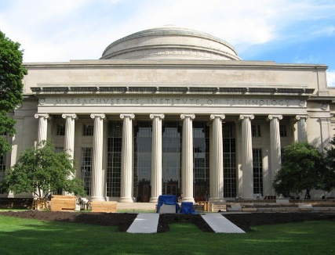 **RMW17**

**The 17th Workshop on Reactive Metal Processing**

**March 8 (Fri.) - 9 (Sat.), 2024 @ MIT**

(After TMS 2024, March 3 - March 7, 2024 @ Orlando, Florida)



**Organizers:**

**Donald R. Sadoway**, *Massachusetts Institute of Technology*

**Toru H. Okabe**, *Institute of Industrial Science (IIS),*

*The University of Tokyo*

**Antoine Allanore**, *Massachusetts Institute of Technology*

**Shunsuke Yagi**, *IIS, The University of Tokyo*

**Program Coordinators:**

**Takanari Ouchi**,*IIS*, *The University of Tokyo*

**Gen Kamimura**,*Massachusetts Institute of Technology*

**Isaac Oda-Bayliss**,*IIS*, *The University of Tokyo*

**TBD**, *Massachusetts Institute of Technology*

http://www.okabe.iis.u-tokyo.ac.jp/core-to-core/rmw/

History of RMW

2006 **The 1st Workshop on Reactive Metal Processing (RMW1)**

March 17 (Fri.) - March 19 (Sat.), Cambridge, MIT

2006 **The 2nd Workshop on Reactive Metal Processing (RMW2)**

November 16 (Thurs.) - November 17 (Fri.), Tokyo, The University of Tokyo

2007 **The 3rd Workshop on Reactive Metal Processing (RMW3)**

March 2 (Fri.) - March 3 (Sat.), Cambridge, MIT

2008 **The 4th Workshop on Reactive Metal Processing (RMW4)**

March 14 (Fri.) - March 15 (Sat.), Cambridge, MIT

2010 **The 5th Workshop on Reactive Metal Processing (RMW5)**

February 18 (Thurs.) - February 19 (Fri.), Seattle, Red Lion Hotel on 5th Avenue

2011 **The 6th Workshop on Reactive Metal Processing (RMW6)**

March 4 (Fri.) - March 5 (Sat.), Pasadena, Caltech

2012 **The 7th Workshop on Reactive Metal Processing (RMW7)**

March 16 (Fri.) - March 17 (Sat.), Cambridge, MIT

2013 **The 8th Workshop on Reactive Metal Processing (RMW8)**

March 8 (Fri.) - March 9 (Sat.), Cambridge, MIT

2014 **The 9th Workshop on Reactive Metal Processing (RMW9)**

February 21 (Fri.) - February 22 (Sat.), Pasadena, Caltech

2015 **The 10th Workshop on Reactive Metal Processing (RMW10)**

March 20 (Fri.) - March 21 (Sat.), Cambridge, MIT

2016 **The 11th Workshop on Reactive Metal Processing (RMW11)**

February 19 (Fri.) - February 20 (Sat.), Cambridge, MIT

2017 **The 12th Workshop on Reactive Metal Processing (RMW12)**

March 3 (Fri.) - March 4 (Sat.), Cambridge, MIT

2018 **The 13th Workshop on Reactive Metal Processing (RMW13)**

March 16 (Fri.) - March 17 (Sat.), Cambridge, MIT

2019 **The 14th Workshop on Reactive Metal Processing (RMW14)**

March 15 (Fri.) - March 16 (Sat.), Cambridge, MIT

2020 **The 15th Workshop on Reactive Metal Processing (RMW15)**

February 28 (Fri.) - February 29 (Sat.), San Diego, UC San Diego

2023 **The 16th Workshop on Reactive Metal Processing (RMW16)**

March 24 (Fri.) - March 25 (Sat.), Cambridge, MIT

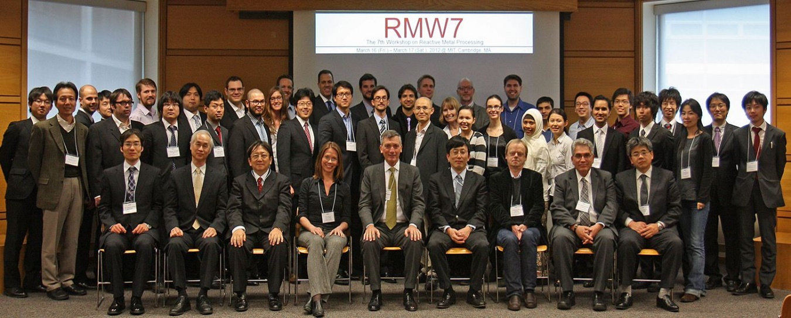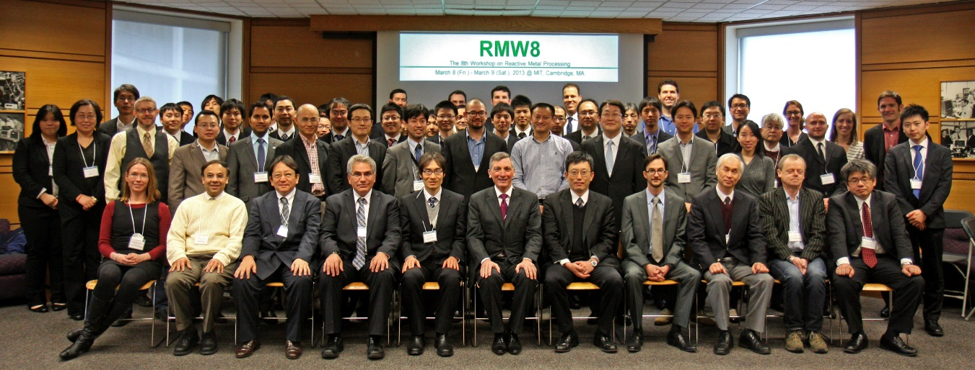(Due to COVID-19, the event was postponed from its scheduled date in 2021.)

2024 **The 17th Workshop on Reactive Metal Processing (RMW17, planned)**

March 8 (Fri.) - March 9 (Sat.), Cambridge, MIT

会議室に集まる人々

**RMW 16, MIT, Cambridge, Mar. 24-25, 2023**

**Contact:**

**Takanari Ouchi,** *The University of Tokyo*

**E-mail: t-ouchi@iis.u-tokyo.ac.jp**