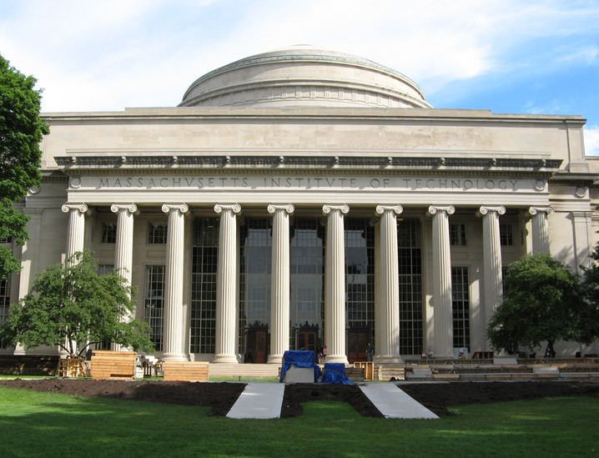
RMW10

The 10th Workshop on Reactive Metal Processing
March 20 (Fri.) - 21 (Sat.), 2015
@ MIT, Cambridge

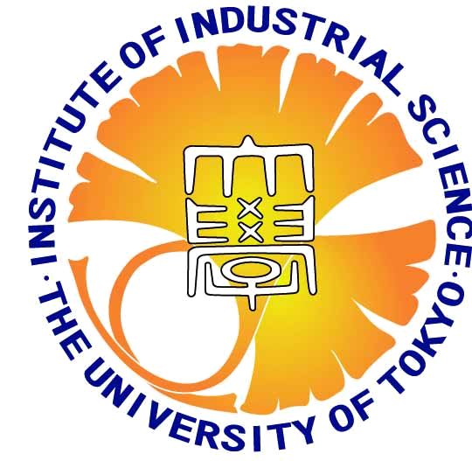

Organizers:
Prof. Toru H. Okabe, Institute of Industrial Science (IIS),
The University of Tokyo
Prof. Antoine Allanore, Massachusetts Institute of Technology
Prof. Donald R. Sadoway, Massachusetts Institute of Technology

Program Coordinators:
Jungshin Kang, IIS, The University of Tokyo
(currently at KIGAM in Korea)
Katsuhiro Nose, IIS, The University of Tokyo
(currently at MIT)

http://www.okabe.iis.u-tokyo.ac.jp/core-to-core/rmw/

History of RMW

2006 The 1st Workshop on Reactive Metal Processing (RMW1)
March 17 (Fri.) - March 19 (Sat.), Cambridge, MIT
2006 The 2nd Workshop on Reactive Metal Processing (RMW2)
November 16 (Thurs.) - November 17 (Fri.), Tokyo, The University of Tokyo
2007 The 3rd Workshop on Reactive Metal Processing (RMW3)
March 2 (Fri.) - March 3 (Sat.), Cambridge, MIT
2008 The 4th Workshop on Reactive Metal Processing (RMW4)
March 14 (Fri.) - March 15 (Sat.), Cambridge, MIT
2010 The 5th Workshop on Reactive Metal Processing (RMW5)
February 18 (Thurs.) - February 19 (Fri.), Seattle, Red Lion Hotel on 5th Avenue
2011 The 6th Workshop on Reactive Metal Processing (RMW6)
March 4 (Fri.) - March 5 (Sat.), Pasadena, Caltech
2012 The 7th Workshop on Reactive Metal Processing (RMW7)
March 16 (Fri.) - March 17 (Sat.), Cambridge, MIT
2013 The 8th Workshop on Reactive Metal Processing (RMW8)
March 8 (Fri.) - March 9 (Sat.), Cambridge, MIT
2014 The 9th Workshop on Reactive Metal Processing (RMW9)
February 21 (Fri.) - February 22 (Sat.), Pasadena, Caltech

