RMW11
The 11th Workshop on Reactive Metal Processing
February 19 (Fri.) - 20 (Sat.), 2016 @ MIT
Cambridge, Massachusetts, USA

Organizers
Donald R. Sadoway, Massachusetts Institute of Technology
Toru H. Okabe, Institute of Industrial Science (IIS),
The University of Tokyo
Antoine Allanore, Massachusetts Institute of Technology

Program Coordinators
Sakae Shirayama, The University of Tokyo
Yu-ki Taninouchi, IIS, The University of Tokyo

http://www.okabe.iis.u-tokyo.ac.jp/core-to-core/rmw

The 11th Workshop on Reactive Metal Processing
February 19 (Fri.) – February 20 (Sat.), 2016, MIT, Cambridge, MA

Time:
- 1st day: on February 19 (9:20 – 17:50 and Banquet in 18:30)
- 2nd day: on February 20 (9:20 – 13:00)
Refreshments will be served around 9:00 AM at the Grier room in both days.
Venue:
- Grier Room for Workshop (Building 34, Room 401) (see page 12)
Poster session is held at the Grier Room on February 19, 2016.
- Le Meridien Hotel for Banquet
(see page 12 or http:// www.lemeridiencambridge.com/)
Organizers:
Prof. Donald R. Sadoway, Massachusetts Institute of Technology
Prof. Toru H. Okabe, IIS, The University of Tokyo
Prof. Antoine Allanore, Massachusetts Institute of Technology
Program Coordinators:
Dr. Sakae Shirayama, The University of Tokyo
Dr. Yu-ki Taninouchi, IIS, The University of Tokyo
Sponsors:
- Strategic Young Researcher Overseas Visits Program for Accelerating
Brain Circulation by JSPS (P.I.: Prof. T.H. Okabe)
- The Rare Metal Research Workshop, one of the Special Research Group
organized by the Foundation for the Promotion of Industrial Science
(FPIS) (RC-40: directed by Prof. T.H. Okabe)
- Grant-in-Aid for Scientific Research (S) by JSPS (Project No. 26220910)
- The Strategic Partnerships Project of the Top Global University Project by
The University of Tokyo
Registration Fee:
$200 / person (including banquet)
NOTICE: Please prepare to pay the registration fee in cash!
Contact:
Sakae Shirayama, The University of Tokyo
E-mail: shirayama@material.t.u-tokyo.ac.jp Phone: +81-3-5841-8290
Workshop Program
Day 1 Morning, February 19 (Friday), 2016 @ Grier Room

9:00 – 9:20 Coffee & Breakfast Service
9:20 – 9:30 Opening Remarks
Prof. Donald R. Sadoway, Massachusetts Institute of Technology
Prof. Toru H. Okabe, IIS, The University of Tokyo

Session Chair: Dr. Kouji Yasuda
9:30 – 10:00 “Reactive systems under own pressures”
Georges J. Kipouros¹
¹University of Saskatchewan

10:00 – 10:30 “Electrochemical properties of alkali/alkaline-earth element in liquid metals”
Hojong Kim¹
¹The Pennsylvania State University

10:30 – 11:00 “Fluorination behavior of actinide elements for fuel debris treatment”
Nobuaki Sato¹
¹Institute of Multidisciplinary Research for Advanced Materials (IMRAM),
^{x}Tohoku University

11:00 – 11:15 Break

Session Chair: Dr. Adam C. Powell, IV
11:15 – 11:45 “Urban mining to recover metal values: Electrodeposition of tin and indium
in molten chloride electrolytes”
Geir Martin Haarberg¹ and Bo Qin²
¹Norwegian University of Science and Technology (NTNU)
²Kunming University of Science and Technology

11:45 – 12:15 “Behavior of impurities in aluminum electrowinning, and the effect on current efficiency”
Guðrún Sævarsdóttir¹
¹Reykjavik University

12:15 – 13:15 Lunch
Afternoon, February 19 (Friday), 2016 @ Grier Room

Session Chair: Prof. Qian Xu
13:15 – 13:45 “Electrochemistry of liquid metals and molten salts”
Donald R. Sadoway¹
¹Department of Materials Science and Engineering,
^{x}Massachusetts Institute of Technology

13:45 – 14:15 “Li-Bi for low-temperature liquid metal batteries”
Huayi Yin¹, Brice Chung¹, and Donald R. Sadoway¹
¹Department of Materials Science and Engineering,
^{x}Massachusetts Institute of Technology

14:15 – 14:30 Break

Session Chair: Prof. Antoine Allanore
14:30 – 15:00 “Development of direct liquid steel production by electrolysis in molten oxides”
Jan Wiencke^{1,2}, Hervé Lavelaine¹, Pierre-Jean Panteix², Carine Petitjean², and Christophe Rapin²
¹ArcelorMittal Maizières
²Institut Jean Lamour, Université de Lorraine

15:00 – 15:30 “Controlled molten oxidation of copper slag”
Yong Fan¹, Etsuro Shibata¹, Atsushi Iizuka¹, and Takashi Nakamura¹
¹Institute of Multidisciplinary Research for Advanced Materials (IMRAM),
^{x}Tohoku University

15:30 – 16:00 Photo & Break

16:00 – 16:50 3-min short presentation by poster presenters

16:50 – 17:50 Poster Session

18:30 – Banquet @ Le Meridien Hotel

Day 2
Morning, February 20 (Saturday), 2016 @ Grier room

9:00 – 9:20 Coffee & Breakfast Service
9:20 – 9:30 Opening Remarks
Prof. Antoine Allanore, Massachusetts Institute of Technology

Session Chair: Prof. Geir Martin Haarberg
9:30 – 10:00 “Production of high-purity silicon via molten salt electrolysis”
Xiao Yang¹, Kouji Yasuda^{2,3}, Toshiyuki Nohira¹, Rika Hagiwara³, and
Takayuki Homma⁴
¹Institute of Advanced Energy, Kyoto University
²Environment, Safety and Health Organization, Kyoto University
³Graduate School of Energy Science, Kyoto University
⁴Faculty of Science and Engineering, Waseda University

10:00 – 10:30 “Introduction to recent studies on recycling processes for metals in scraps of
electronic devices and superconducting materials”
Hideaki Sasaki¹
¹Institute of Industrial Science, The University of Tokyo

10:30 – 10:45 Break

Session Chair: Prof. Georges J. Kipouros
10:45 – 11:15 “Recent progresses on electrochemistry of molten semiconductors”
Antoine Allanore¹
¹Massachusetts Institute of Technology

11:15 – 11:45 “Towards measurement of thermodynamic properties of molten rare earth oxides”
Bradley R. Nakanishi¹ and Antoine Allanore¹
¹Department of Materials Science and Engineering,
^{x}Massachusetts Institute of Technology

11:45 – 11:50 Information for the Next RMW
Prof. Toru H. Okabe, IIS, The University of Tokyo
11:50 – 12:00 Closing Remarks
Prof. Donald R. Sadoway, Massachusetts Institute of Technology
Afternoon, February 20 (Saturday), 2016 @ Grier Room

12:00 – 13:00 Lunch

13:00 – Laboratory Tour (for applicants)
List of Poster Presentations

- “Fundamental study on Bi-Ti-Zn ternary phase diagram for new smelting process of titanium”
Akihiro Kishimoto¹ and Tetsuya Uda¹
¹Department of Materials Science and Engineering, Kyoto University

- “Overpotential measurement for magnesium electrolysis on bismuth electrode”
Kazuhiro Kumamoto¹, Akihiro Kishimoto¹, and Tetsuya Uda¹
¹Department of Materials Science and Engineering, Kyoto University

- “Analysis of the hydration/dehydration behavior of lanthanum sulfate for chemical heat storage”
Kunihiko Shizume¹, Naoyuki Hatada¹, and Tetsuya Uda¹
¹Department of Materials Science and Engineering, Kyoto University

- “Electroplating of Si in high temperature fluoride-chloride melt”
Kouji Yasuda^{1,2}, Kazumi Saeki², Toshiyuki Nohira³, Rika Hagiwara², and
Takayuki Homma⁴
¹Environment, Safety and Health Organization, Kyoto University
²Graduate School of Energy Science, Kyoto University
³Institute of Advanced Energy, Kyoto University
⁴Faculty of Science and Engineering, Waseda University

- “Segregation refinement of Si utilizing liquid Zn”
Kouji Yasuda^{1,2}, Akifumi Ido², Xiao Yang³, Toshiyuki Nohira³, Rika Hagiwara², and
Takayuki Homma⁴
¹Environment, Safety and Health Organization, Kyoto University
²Graduate School of Energy Science, Kyoto University
³Institute of Advanced Energy, Kyoto University
⁴Faculty of Science and Engineering, Waseda University

- “Preparing silicide layers on metallic substrates using molten oxide electrolysis”
Hideaki Sasaki¹ and Masafumi Maeda¹
¹Institute of Industrial Science, The University of Tokyo

- “Thermodynamics of rare earth elements in nodular cast iron”
Ng Kok Long^{1,2}, Hisao Kimura², Hideaki Sasaki², and Masafumi Maeda²
¹Department of Materials Engineering, The University of Tokyo
²Institute of Industrial Science, The University of Tokyo
- “Investigation of the passivation mechanism of copper-based anodes from in-situ observations”
Yuma Ninomiya^{1,2}, Hideaki Sasaki², and Masafumi Maeda²
¹Department of Materials Engineering, The University of Tokyo
²Institute of Industrial Science, The University of Tokyo

- “Thermodynamic properties of the CaO-AlO_{1.5}-CeO_{1.5} system”
Ryo Kitano¹ and Kazuki Morita¹
¹Department of Materials Engineering, The University of Tokyo

- “Development of new technologies for high-speed production of copper”
Kanta Iwaya^{1,2} and Toru H. Okabe²
¹Department of Materials Engineering, The University of Tokyo
²Institute of Industrial Science, The University of Tokyo

- “Nickel and rhenium separation from nickel-based superalloy scraps using zinc circulation”
Ryohei Yagi^{1,2} and Toru H. Okabe²
¹Department of Materials Engineering, The University of Tokyo
²Institute of Industrial Science, The University of Tokyo

- “A review of the extraction of rare earth elements as a by-product of uranium mining”
William D. Judge¹ and Georges J. Kipouros¹
¹Chemical Engineering, College of Engineering, University of Saskatchewan

- “Porous carbon anodes for the supply of methane during electrowinning of aluminium”
Babak Khalaghi¹, Henrik Gudbrandsen², Ole Sigmund Kjos², Karen Sende Osen²,
Tommy Mokkelbost², and Geir Martin Haarberg¹
¹Department of Materials Science and Engineering,
^{x}Norwegian University of Science and Technology (NTNU)
²SINTEF Materials and Chemistry

- “Electrochemically active surface area of carbon anodes in molten salt”
Wojciech Gebarowski¹, Arne Petter Ratvik³, Stein Rørvik³, Espen Sandnes¹,
Lorentz Petter Lossius², Hogne Linga², and Ann Mari Svensson¹
¹Department of Materials Science and Engineering,
^{x}Norwegian University of Science and Technology (NTNU)
²Hydro Aluminium
³SINTEF Materials and Chemistry

- “Controllable electrolytic production of metal carbides and composites in molten salt”
Xingli Zou¹, Xionggang Lu¹, Qian Xu¹, and Zhongfu Zhou¹
¹State Key Laboratory of Advanced Special Steel,
^{x}School of Materials Science and Engineering, Shanghai University

- “In situ measurements of current density distribution”
Brian Chmielowiec¹ and Antoine Allanore¹
¹Department of Materials Science and Engineering, Massachusetts Institute of Technology

- “Electrodeposition/stripping of Mg in organic electrolytes for Mg batteries”
Shunsuke Yagi¹
¹Nanoscience and Nanotechnology Research Center, Osaka Prefecture University

- “Alloying treatment for platinum by using FeCl₂ vapor”
Yu-ki Taninouchi¹ and Toru H. Okabe¹
¹Institute of Industrial Science, The University of Tokyo

History of RMW

2006 The 1st Workshop on Reactive Metal Processing (RMW1)
March 17 (Fri.) - March 19 (Sat.), Cambridge, MIT
2006 The 2nd Workshop on Reactive Metal Processing (RMW2)
November 16 (Thurs.) - November 17 (Fri.), Tokyo, The University of Tokyo
2007 The 3rd Workshop on Reactive Metal Processing (RMW3)
March 2 (Fri.) - March 3 (Sat.), Cambridge, MIT
2008 The 4th Workshop on Reactive Metal Processing (RMW4)
March 14 (Fri.) - March 15 (Sat.), Cambridge, MIT
2010 The 5th Workshop on Reactive Metal Processing (RMW5)
February 18 (Thurs.) - February 19 (Fri.), Seattle, Red Lion Hotel on 5th Avenue
2011 The 6th Workshop on Reactive Metal Processing (RMW6)
March 4 (Fri.) - March 5 (Sat.), Pasadena, Caltech
2012 The 7th Workshop on Reactive Metal Processing (RMW7)
March 16 (Fri.) - March 17 (Sat.), Cambridge, MIT
2013 The 8th Workshop on Reactive Metal Processing (RMW8)
March 8 (Fri.) - March 9 (Sat.), Cambridge, MIT
2014 The 9th Workshop on Reactive Metal Processing (RMW9)
February 21 (Fri.) - February 22 (Sat.), Pasadena, Caltech
2015 The 10th Workshop on Reactive Metal Processing (RMW10)
March 20 (Fri.) - March 21 (Sat.), Cambridge, MIT
List of Participants February 20, 2016

Adam C. Powell, IV Chief Technology Officer INFINIUM, Inc.
Akihiro Kishimoto Ph.D. Candidate Kyoto University
Andrew H. Caldwell Ph.D. Candidate MIT
Antoine Allanore Assistant Professor MIT
Babak Khalaghi Ph.D. Candidate NTNU
Bradley R. Nakanishi Ph.D. Candidate MIT
Brian Chmielowiec Research Engineer MIT
Camilla Sommerseth Researcher SINTEF Materials and Chemistry
Donald R. Sadoway Professor MIT
Egil Skybakmoen Research Director SINTEF Materials and Chemistry
Fumio Iwamoto Executive Chief Engineer Sumitomo Metal Mining CO., LTD.
Geir M. Haarberg Professor NTNU
Georges J. Kipouros Professor University of Saskatchewan
Guðrún Sævarsdóttir Professor Reykjavik University
Hideaki Sasaki Research Associate The University of Tokyo
Hojong Kim Assistant Professor The Pennsylvania State University
Hilary Sheldon Administrative Staff MIT, Prof. Sadoway’s secretary
Huayi Yin Postdoctoral Associate MIT
Jan Wiencke Ph.D. Candidate Université de Lorraine
Junjun Peng Professor Wuhan Textile University
Kanta Iwaya Graduate Student The University of Tokyo
Kathie McGregor Group Leader CSIRO
Katsuhiro Nose Project Research Associate The University of Tokyo
Kazuhiro Kumamoto Graduate Student Kyoto University
Kazuki Morita Professor The University of Tokyo
Kok Long Ng Graduate Student The University of Tokyo
Kouji Yasuda Assistant Professor Kyoto University
Kunihiko Shizume Graduate Student Kyoto University
Mana Inukai Administrative Staff The University of Tokyo
Minoru Kawasaki President NIPPON PGM AMERICA, Inc.
Nobuaki Sato Professor IMRAM, Tohoku University
Qian Xu Professor Shanghai University
Ryo Kitano Graduate Student The University of Tokyo
Ryo Togashi Deputy Manager Sumitomo Metal Mining CO., LTD.
Ryohei Yagi Graduate Student The University of Tokyo
Sakae Shirayama Research Associate The University of Tokyo
Shunsuke Yagi Special Lecturer Osaka Prefecture University
Sulata Kumari Sahu Postdoctoral Associate MIT
Takanari Ouchi Research Scientist MIT
Takayuki Hashimoto Administrative Staff The University of Tokyo
Tomoko Yanagisawa Leader of Marketing Dept. TANAKA HOLDINGS CO., Ltd.
Toru H. Okabe Professor The University of Tokyo
William Judge Ph.D. Candidate University of Saskatchewan
Wojciech Gebarowski Postdoctoral Associate NTNU
Xiao Yang Project Research Associate Kyoto University
Xingli Zou Lecturer Shanghai University
Yong Fan Ph.D. Candidate IMRAM, Tohoku University
Youyang Zhao Ph.D. Candidate MIT
Yu-ki Taninouchi Research Associate The University of Tokyo
Yuma Ninomiya Graduate Student The University of Tokyo
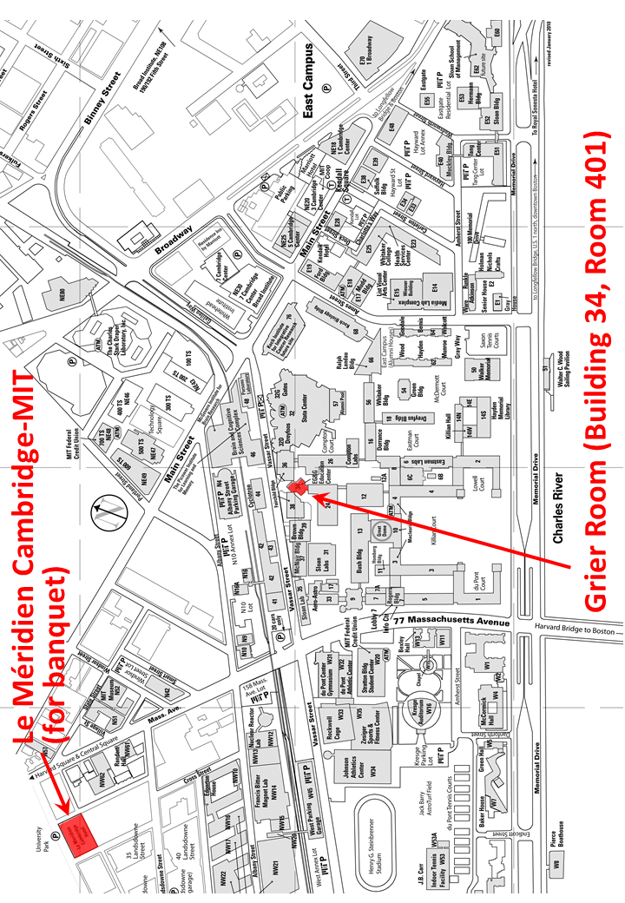

Announcement for Next Workshop

RMW12
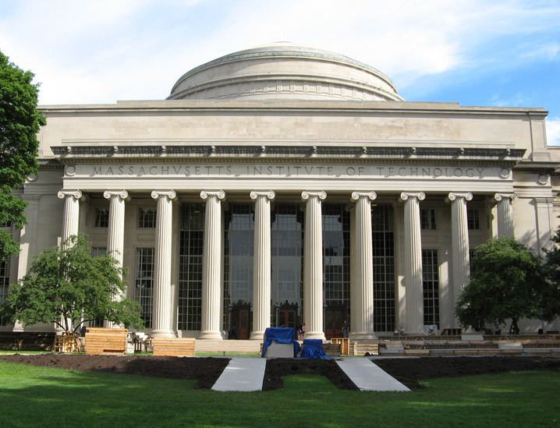

The 12th Workshop on
Reactive Metal Processing

March 3 (Fri.) – 4 (Sat.), 2017 @ MIT, Cambridge

(After TMS 2017, February 26 – March 2, 2017
@ San Diego, California)

Organizers
Antoine Allanore, Massachusetts Institute of Technology
Shunsuke Yagi, IIS, The University of Tokyo
Toru H. Okabe, IIS, The University of Tokyo
Donald R. Sadoway, Massachusetts Institute of Technology

Program Coordinators
Yu-ki Taninouchi, IIS, The University of Tokyo
Ryohei Yagi, IIS, The University of Tokyo
Bradley R. Nakanishi, Massachusetts Institute of Technology

http://www.okabe.iis.u-tokyo.ac.jp/core-to-core/rmw/

