RMW12
The 12th Workshop on Reactive Metal Processing
March 3 (Fri.) - 4 (Sat.), 2017 @ MIT
Cambridge, Massachusetts, USA

Organizers
Antoine Allanore, Massachusetts Institute of Technology
Shunsuke Yagi, Institute of Industrial Science (IIS),
The University of Tokyo
Toru H. Okabe, IIS, The University of Tokyo
Donald R. Sadoway, Massachusetts Institute of Technology

Program Coordinators
Ryohei Yagi, IIS, The University of Tokyo
Bradley R. Nakanishi, Massachusetts Institute of Technology
Yu-ki Taninouchi, IIS, The University of Tokyo

Sponsors
-The Rare Metal Research Workshop, one of the Special Research Group
organized by the Foundation for the Promotion of Industrial Science
(FPIS) (RC-40: directed by Prof. T. H. Okabe)
-Donation to The University of Tokyo New York Office
by Dowa Metals & Mining Co., Ltd., Mitsubishi Materials Corporation,
Sumitomo Metal Mining Co., Ltd., and Tanaka Kikinzoku Kogyo K.K..
-IIS UTokyo Symposium # 87 by the Foundation for the Promotion of Industrial Science (FPIS)
-Grant-in-Aid for Scientific Research (S) by JSPS (Project No. 26220910)
-The Strategic Partnerships Project of the Top Global University Project by
The University of Tokyo

http://www.okabe.iis.u-tokyo.ac.jp/core-to-core/rmw

The 12th Workshop on Reactive Metal Processing
March 3 (Fri.) – March 4 (Sat.), 2017, MIT, Cambridge, MA

Time:
- 1st day: on March 3 (9:30 – 17:15 and Banquet at 18:30)
- 2nd day: on March 4 (9:30 – 13:30)
Refreshments will be served around 8:30 AM on both days.
Venue:
- Microsoft NERD Center for Workshop (Horace Mann Room)
Poster session is held at the Microsoft NERD Center on March 3, 2017.
- MIT Museum for Banquet (https://mitmuseum.mit.edu/)
Registration Fee:
$200 / person ($50 for students)
NOTICE: Please prepare to pay the registration fee in cash!
Organizers:
Prof. Antoine Allanore, Massachusetts Institute of Technology
Prof. Shunsuke Yagi, IIS, The University of Tokyo
Prof. Toru H. Okabe, IIS, The University of Tokyo
Prof. Donald R. Sadoway, Massachusetts Institute of Technology
Program Coordinators:
Ryohei Yagi, IIS, The University of Tokyo
Bradley R. Nakanishi, Massachusetts Institute of Technology
Yu-ki Taninouchi, IIS, The University of Tokyo
Sponsors:
- The Rare Metal Research Workshop, one of the Special Research Group
organized by the Foundation for the Promotion of Industrial Science
(FPIS) (RC-40: directed by Prof. T. H. Okabe)
- Donation to The University of Tokyo New York Office
by Dowa Metals & Mining Co., Ltd., Mitsubishi Materials Corporation,
Sumitomo Metal Mining Co., Ltd., and Tanaka Kikinzoku Kogyo K.K.
- IIS UTokyo Symposium # 87 by the Foundation for the Promotion of Industrial Science (FPIS)
- Grant-in-Aid for Scientific Research (S) by JSPS (Project No. 26220910)
- The Strategic Partnerships Project of the Top Global University Project by
The University of Tokyo
Contact:
Ryohei Yagi, IIS, The University of Tokyo
E-mail: r-yagi@iis.u-tokyo.ac.jp
Workshop Program
Day 1 Morning, March 3 (Friday), 2017 @ Horace Mann Room in the Microsoft NERD Center

08:30 – 09:30 Coffee & Breakfast Service

09:30 – 09:40 Opening Remarks
Prof. Donald R. Sadoway, Massachusetts Institute of Technology
Prof. Toru H. Okabe, IIS, The University of Tokyo

Session Chair: Dr. Yu-ki Taninouchi
09:40 – 10:10 “Electrochemical Methods for the Investigation of High Temperature Molten Oxide Systems”
Antoine Allanore¹
¹Massachusetts Institute of Technology

10:10 – 10:40 “Quadruple Perovskite Catalysts for Oxygen Evolution Reaction”
Shunsuke Yagi¹
¹Institute of Industrial Science, The University of Tokyo

10:40 – 10:55 Break

Session Chair: Prof. Georges J. Kipouros
10:55 – 11:25 “Electrodeposition of Silicon for Photovoltaic Applications”
Ji Zhao¹ and Donald R. Sadoway¹
¹Massachusetts Institute of Technology

11:25 – 11:55 “Viscosity Measurement of High-Temperature Melts for Materials Processings”
Osamu Takeda¹
¹Tohoku University

11:55 – 12:25 “Methane-supplied Gas Anodes for Electrowinning of Aluminium”
Babak Khalaghi¹, Tommy Mokkelbost², Ole Sigmund Kjos²,
Geir Martin Haarberg¹
¹Norwegian University of Science and Technology
²SINTEF Materials and Technology

12:25 – 13:30 Lunch
Afternoon, March 3 (Friday), 2017 @ Horace Mann Room in the Microsoft NERD Center

Session Chair: Prof. Shunsuke Yagi
13:30 – 14:00 “The Role of Rare Earths in Energy Conversion Higher Efficient Systems”
Georges J. Kipouros¹
¹University of Saskatchewan

14:00 – 14:30 “Vapor Treatment for Alloying and Magnetizing Platinum Group Metals”
Yu-ki Taninouchi and Toru H. Okabe¹
¹Institute of Industrial Science, The University of Tokyo

14:30 – 15:00 “Investigation and Mitigation of Chromium Poisoning of Perovskite Cathodes at High Temperatures”
Uday B. Pal¹ and Ruofan Wang¹
¹Boston University

15:00 – 15:15 Photo & Break

15:15 – 16:15 3-min Short Presentation by Poster Presenters

16:15 – 17:15 Poster Session

18:30 – Banquet @ MIT Museum

Day 2
Morning, March 4 (Saturday), 2017 @ Horace Mann Room in the Microsoft NERD Center

08:30 – 09:30 Coffee & Breakfast Service

09:30 – 0 9:40 Opening Remarks
Prof. Antoine Allanore, Massachusetts Institute of Technology
Prof. Shunsuke Yagi, IIS, The University of Tokyo

Session Chair: Prof. Osamu Takeda
09:40 – 10:10 “Alternating Current Voltammetry Theory of Metal Reduction during High Temperature Electrolysis”
Andrew Caldwell¹ and Antoine Allanore¹
¹Massachusetts Institute of Technology

10:10 – 10:40 “Quantum Beam Technology: Metallic Nanostructures Prepared by Ion Beam Irradiation for Electrochemical Devices”
Tetsuya Yamaki¹
¹National Institutes for Quantum and Radiological Science and Technology

10:40 – 11:00 Break

Session Chair: Prof. Antoine Allanore
11:00 – 11:30 “Electrodeposition of Titanium in MgCl₂-NaCl-KCl”
Kouhei Funatsu¹, Yuki Yamada¹, Akihiro Kishimoto¹, and Tetsuya Uda¹
¹Department of Materials Science and Engineering, Kyoto University

11:30 – 12:00 “Effect of Additives on Current Efficiency for Aluminium Deposition from Cryolite-Based Electrolytes”
Taiki Morishige^{1,2}, Geir Martin Haarberg¹, Henrik Gudbrandsen³,
Egil Skybakmoen³, and Asbjørn Solheim³
¹Norwegian University of Science and Technology
²Kansai University
³SINTEF Materials and Chemistry

12:00 – 12:10 Information for the Next RMW
Prof. Toru H. Okabe, IIS, The University of Tokyo
12:10 – 12:20 Closing Remarks
Prof. Donald R. Sadoway, Massachusetts Institute of Technology

12:20 – 13:30 Lunch

13:30 – Laboratory Tour (for applicants)
List of Poster Presentations

- “Thermal Imaging Furnace Technique for Ultra-High Temperature Electrochemical Measurements”
Bradley Nakanishi¹ and Antoine Allanore¹
¹Massachusetts Institute of Technology

- “Scaling Up Molten Sulfide Electrolysis: Electrochemical Engineering Considerations”
Brian Chmielowiec¹ and Antoine Allanore¹
¹Massachusetts Institute of Technology

- “Molten Semiconductors for High Temperature Thermoelectricity”
Youyang Zhao¹ and Antoine Allanore¹
¹Massachusetts Institute of Technology

- “Extraction of Cu, Mo and Re from Sulfide Electrolyte Melt”
Sulata Kumari Sahu¹ and Antoine Allanore¹
¹Massachusetts Institute of Technology

- “Phase Equilibria in the BaO-ZrO₂-Y₂O₃-NiO System at 1500ºC”
Katsuhiro Ueno¹, Naoyuki Hatada¹, Donglin Han¹, Yuki Otani¹, Akiko Kuramitsu¹,
and Tetsuya Uda¹
¹Department of Materials Science and Engineering, Kyoto University

- “Investigation of La₂(M_{1-x}RE_{x})₂O₇-_{δ} (M = Nb, Ta ; RE = Rare Earth Element) Based Ionic Conductor”
Kouhei Kato¹, Donglin Han¹, and Tetsuya Uda¹
¹Department of Materials Science and Engineering, Kyoto University

- “Non-Empirical Calculation of Thermodynamic Properties of Liquid Transition Metal Alloys”
Shun Ueda¹ and Kazuki Morita¹
¹Department of Materials Engineering, The University of Tokyo

- “Heterogeneous Nucleation Mechanism of Copper Sulfate Hydrate on Copper Alloys”
Yuma Ninomiya^{1,2} Hideaki Sasaki³, Takeshi Yoshikawa², and Masafumi Maeda²
¹Department of Materials Engineering, The University of Tokyo
²Institute of Industrial Science, The University of Tokyo
³Materials Science and Engineering, Graduate School of Science and Engineering, Ehime University
- “Evaluation on the Heterogeneous Nucleation of Graphite on Non-Metallic Inclusions in Fe-C-Si Alloys”
Kok Long NG^{1,2}, Hideaki Sasaki³, Hisao Kimura², Takeshi Yoshikawa², and Masafumi Maeda² ¹Department of Materials Engineering, The University of Tokyo
²Institute of Industrial Science, The University of Tokyo
³Materials Science and Engineering, Graduate School of Science and Engineering, Ehime University

- “Development of Novel Recycling Process of Precious Metals from Waste of Electrical Electronic Equipment Using Organic Aqua Regia”
Akihiro Yoshimura¹ and Yasunari Matsuno²
¹Institute of Industrial Science, the University of Tokyo
²Graduate School of Engineering, Chiba University

- “Nickel and Rhenium Separation from Ni-based Superalloy Scraps by Using Molten Bi-Zn”
Ryohei Yagi^{1,2} and Toru H. Okabe²
¹Department of Materials Engineering, The University of Tokyo
²Institute of Industrial Science, The University of Tokyo

- “Development of New Technology for High-Speed Production of Copper”
Kanta Iwaya^{1,2} and Toru H. Okabe²
¹Department of Materials Engineering, The University of Tokyo
²Institute of Industrial Science, The University of Tokyo

- “Thermodynamic Considerations of Titanium Deoxidation by Rare-Earth Metals”
Chenyi Zheng ^{1,2}, Yu-ki Taninouchi², and Toru H. Okabe²
¹Department of Materials Engineering, The University of Tokyo
²Institute of Industrial Science, The University of Tokyo

- “Performance of iridium containing nickel base superalloy tool for friction stir welding of Ti-6Al-4V alloy”
Kunihiro Tanaka¹, Tatsuya Nakazawa¹, Koichi Sakairi¹, Yutaka S. Sato², Hiroyuki Kokawa²,
Toshihiro Omori², Kiyohito Ishida², and Satoshi Hirano³
¹ Tanaka Kikinzoku Kogyo K.K.
² Tohoku University
³ Hitachi, Ltd.

- “Workshop on Reactive Metal Processing (Introduction of RMWs)”
History of RMW

2006 The 1st Workshop on Reactive Metal Processing (RMW1)
March 17 (Fri.) - March 19 (Sat.), Cambridge, MIT
2006 The 2nd Workshop on Reactive Metal Processing (RMW2)
November 16 (Thurs.) - November 17 (Fri.), Tokyo, The University of Tokyo
2007 The 3rd Workshop on Reactive Metal Processing (RMW3)
March 2 (Fri.) - March 3 (Sat.), Cambridge, MIT
2008 The 4th Workshop on Reactive Metal Processing (RMW4)
March 14 (Fri.) - March 15 (Sat.), Cambridge, MIT
2010 The 5th Workshop on Reactive Metal Processing (RMW5)
February 18 (Thurs.) - February 19 (Fri.), Seattle, Red Lion Hotel on 5th Avenue
2011 The 6th Workshop on Reactive Metal Processing (RMW6)
March 4 (Fri.) - March 5 (Sat.), Pasadena, Caltech
2012 The 7th Workshop on Reactive Metal Processing (RMW7)
March 16 (Fri.) - March 17 (Sat.), Cambridge, MIT
2013 The 8th Workshop on Reactive Metal Processing (RMW8)
March 8 (Fri.) - March 9 (Sat.), Cambridge, MIT
2014 The 9th Workshop on Reactive Metal Processing (RMW9)
February 21 (Fri.) - February 22 (Sat.), Pasadena, Caltech
2015 The 10th Workshop on Reactive Metal Processing (RMW10)
March 20 (Fri.) - March 21 (Sat.), Cambridge, MIT
2016 The 11th Workshop on Reactive Metal Processing (RMW11)
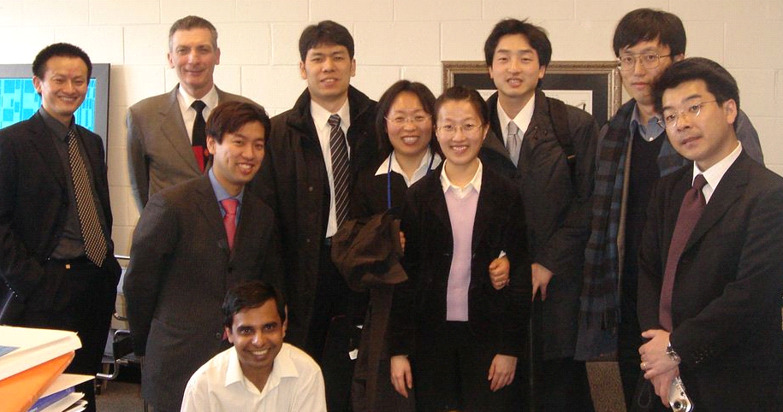
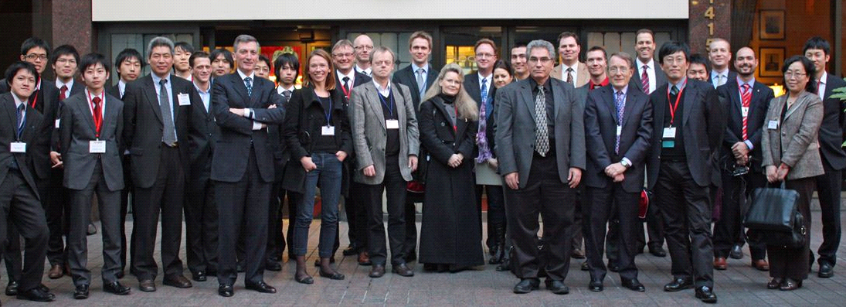
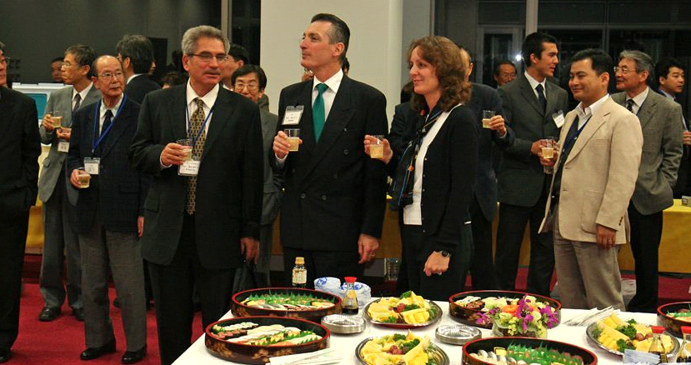
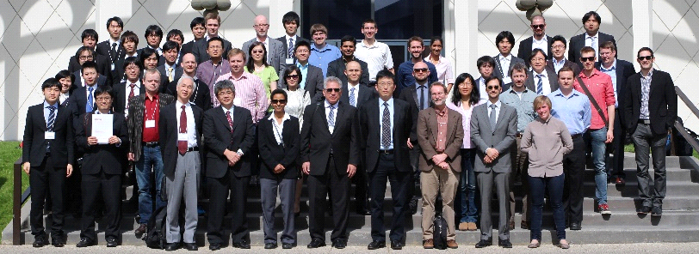
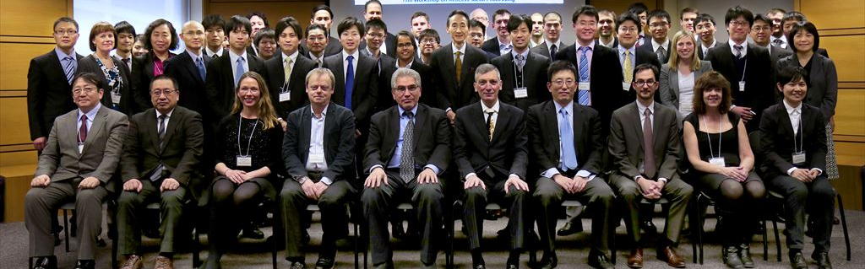
February 19 (Fri.) - February 20 (Sat.), Cambridge, MIT
RMW11 in 2016 at MIT
RMW5 in 2010 in Seattle
RMW9 in 2014 at CALTECH
RMW1 in 2006 at MIT
RMW2 in 2006 at IIS

Announcement for Next Workshop

RMW13
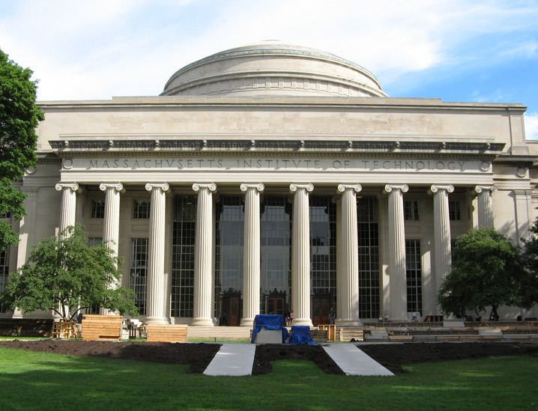

The 13th Workshop on
Reactive Metal Processing

March 16 (Fri.) – 17 (Sat.), 2018 @ MIT, Cambridge

(After TMS 2018, March 11 – March 15, 2018
@ Phoenix, Arizona)

Organizers
Antoine Allanore, Massachusetts Institute of Technology
Shunsuke Yagi, IIS, The University of Tokyo
Toru H. Okabe, IIS, The University of Tokyo
Donald R. Sadoway, Massachusetts Institute of Technology

Program Coordinators
Ryohei Yagi, IIS, The University of Tokyo
Mary E. Wagner, Massachusetts Institute of Technology

http://www.okabe.iis.u-tokyo.ac.jp/core-to-core/rmw/

List of Participants

Akihiro Yoshimura | Project Researcher | The University of Tokyo
Andrew Caldwell | Ph.D Candidate | MIT
Antoine Allanore | Assistant Professor | MIT
Babak Khalaghi | Ph.D Candidate | NTNU
Benjamin Sabatini | Postdoctoral Research Specialist | MIT
Bradley R. Nakanishi | Ph.D Candidate | MIT
Brian Chmielowiec | Graduate Student | MIT
Chenyi Zheng | Graduate Student | The University of Tokyo
Donald R. Sadoway | Professor | MIT
Georges J. Kipouros | Professor | University of Suskatchewan
Hilary Sheldon | Administrative Staff | MIT, Prof. Sadoway's secretary
Hiroyuki Matsuura | Associate Professor | The University of Tokyo
Huayi Yin | Postdoctoral Associate | MIT
Ji Zhao | Postdoctoral Associate | MIT
Kanta Iwaya | Graduate Student | The University of Tokyo
Katsuhiro Ueno | Graduate Student | Kyoto University
Kazuki Morita | Professor | The University of Tokyo
Kouhei Funatsu | Graduate Student | Kyoto University
Kouhei Kato | Graduate Student | Kyoto University
Kunihiro Tanaka | Section Chief Manager | Tanaka Kikinzoku Kogyo K.K.
Mary E. Wagner | Graduate Student | MIT
Masanori Matsumine | Administrative Staff | The University of Tokyo
Minoru Kawasaki | President | Nippon PGM AMERICA, INC.
Ng Kok Long | Graduate Student | The University of Tokyo
Osamu Takeda | Associate Professor | Tohoku University
Paul Burke
Rebecca Miller
Rina Yamada | Administrative Staff | The University of Tokyo
Ruofan Wang | Ph.D Candidate | Boston University
Ryohei Yagi | Graduate Student | The University of Tokyo
Sal Barriga
Shun Ueda | Graduate Student | The University of Tokyo
Shunsuke Yagi | Associate Professor | The University of Tokyo
Sulata Kumari Sahu | Postdoctral Researcher | MIT
Taiki Morishige | Associate Professor | Kansai University
Takanari Ouchi | Research Scientist | MIT
Tetsuya Uda | Professor | Kyoto University
Tetsuya Yamaki | Project Leader &  Senior Principal Researcher | National Institutes for Quantum and Radiological Science and Technology
Thomas Villalón Jr. | Ph.D Candidate | Boston University
Toru H. Okabe | Professor | The University of Tokyo
Uday B. Pal | Professor | Boston University
Xiaofei Guan | Postdoctoral Fellow | Harvard University
Youyang Zhao | Ph.D Candidate | MIT
Yu Okabe | Undergraduate Student | Saitama University
Yu-ki Taninouchi | Research Associate | The University of Tokyo
Yuma Ninomiya | Graduate Student | The University of Tokyo

