RMW15
The 15th Workshop on Reactive Metal Processing
February 28 (Fri.) - 29 (Sat.), 2020
@ UC San Diego, San Diego
February 26 (Wed.) - 27 (Thurs.), 2020 @ TMS

Organizers:
Donald R. Sadoway, Massachusetts Institute of Technology
Toru H. Okabe, Institute of Industrial Science (IIS),
The University of Tokyo
Antoine Allanore, Massachusetts Institute of Technology
Shunsuke Yagi, IIS, The University of Tokyo
Ying Shirley Meng, University of California, San Diego

Program Coordinators:
Takanari Ouchi, IIS, The University of Tokyo
Caspar Stinn, Massachusetts Institute of Technology

Sponsors
-The Rare Metal Research Workshop, one of the Special Research Group
organized by the Foundation for the Promotion of Industrial Science
(RC-40: directed by Prof. T. H. Okabe)
-Donation to The University of Tokyo New York Office
by Dowa Metals & Mining Co., Ltd., Mitsubishi Materials Corporation,
Sumitomo Metal Mining Co., Ltd., and Tanaka Kikinzoku Kogyo K.K..
- Grant-in-Aid for Scientific Research (S) by JSPS (Project No. 19H05623)
-Integrated Research Center for Sustainable Energy and Materials (IRCSEM)
-The Strategic Partnerships Project of the Top Global University Project by
The University of Tokyo
-Institute of Industrial Science, The University of Tokyo (IIS UTokyo SYMPOSIUM No.105)
http://www.okabe.iis.u-tokyo.ac.jp/core-to-core/rmw

The 15th Workshop on Reactive Metal Processing
(IIS UTokyo SYMPOSIUM No.105)
February 28 (Fri.) – February 29 (Sat.), 2020, UCSD, San Diego, CA

Time:
- 1st day: on February 28 (9:30 – 16:30 and Banquet at 19:00)
- 2nd day: on February 29 (9:30 – 13:30)
Refreshments will be served around 8:30 AM on both days.
Venue:
- Cymer Conference Room (SME)
- La Jolla Shores Hotel
(Transportation will be prepared by Organizers)
Registration Fee:
$200 / person
NOTICE: Please prepare to pay the registration fee in cash!
Organizers:
Prof. Donald R. Sadoway, Massachusetts Institute of Technology
Prof. Toru H. Okabe, IIS, The University of Tokyo
Prof. Antoine Allanore, Massachusetts Institute of Technology
Prof. Shunsuke Yagi, IIS, The University of Tokyo
Prof. Ying Shirley Meng University of California, San Diego
Program Coordinators:
Takanari Ouchi, IIS, The University of Tokyo
Caspar Stinn, Massachusetts Institute of Technology
Sponsors:
-The Rare Metal Research Workshop, one of the Special Research Group
organized by the Foundation for the Promotion of Industrial Science
(RC-40: directed by Prof. T. H. Okabe)
-Donation to The University of Tokyo New York Office
by Dowa Metals & Mining Co., Ltd., Mitsubishi Materials Corporation,
Sumitomo Metal Mining Co., Ltd., and Tanaka Kikinzoku Kogyo K.K..
- Grant-in-Aid for Scientific Research (S) by JSPS (Project No. 19H05623)
-Integrated Research Center for Sustainable Energy and Materials (IRCSEM)
-The Strategic Partnerships Project of the Top Global University Project by
The University of Tokyo
-Institute of Industrial Science, The University of Tokyo
(IIS UTokyo SYMPOSIUM No.105)

Contact:
Caspar Stinn, Massachusetts Institute of Technology
E-mail: rmw@iis.u-tokyo.ac.jp
Workshop Program
Day 1 Morning, February 28 (Friday), 2020 @Cymer Conference Room (SME)

8:30 – 9:30 Coffee & Breakfast Service

9:30 – 9:40 Opening Remarks
Prof. Antoine Allanore Massachusetts Institute of Technology
Prof. Ying Shirley Meng University of California, San Diego

Session Chair: Prof. Antoine Allanore
9:40 – 10:10 Advanced Characterization of Lithium Metal Anode and its Interphases with Electrolytes
Ying Shirley Meng
University of California, San Diego

10:10 – 10:40 Electrochemical Catalysts for Oxygen Reduction Reaction in Zinc-air Batteries
Shunsuke Yagi
The University of Tokyo

10:40 – 10:55 Break

Session Chair: Prof. Hongmin Zhu
10:55 – 11:25 Progress on Molten Sulfide Electrolysis
Antoine Allanore
Massachusetts Institute of Technology

11:25 – 11:55 Thermal Conductivity and Structure of Molten Oxides
Kazuki Morita, Sakae Shirayama, Youngjo Kang, Youngjae Kim, Hodaka Aoki, Shun Ueda
The University of Tokyo

11:55 – 13:00 Lunch
Day 1 Afternoon, February 28 (Friday), 2020 @Cymer Conference Room (SME)

Session Chair: Prof. Toshiyuki Nohira
13:00 – 13:20 Electrochemical deposition and morphology control in molten salts
Hongmin Zhu
Tohoku University

13:20 – 13:40 Aluminum production in times of climate change: how to reduce the carbon footprint
Gudrun Saevarsdottir
Reykjavik University

Session Chair: Prof. Geir Martin Haarberg
13:40 – 14:00 Magnesium Production and Recycling Technology
Adam C. Powell IV
Worcester Polytechnic Institute

14:00 – 14:20 Magnesiothermic Reduction of TiO₂ to High Purity Ti Assisted with Rare Earth Elements
Takanari Ouchi, Takara Tanaka, Toru H. Okabe
The University of Tokyo

14:20 – 14:40 Photo & Break

14:40 – 15:40 3-min Short Presentation by Poster Presenters

15:40 – 16:40 Poster Session at Cymer Conference Room (SME)

16:45 – 17:45 Charter bus travel from Cymer Conference Center to La Jolla Shores Hotel
Pickup at 104 Lyman Ln, outside of SME building at loading dock
18:00 – Reception @ La Jolla Shores Hotel
18:30 – Banquet @ La Jolla Shores Hotel

Day 2
Morning, February 29 (Saturday), 2020 @Cymer Conference Room (SME)

08:30 – 09:30 Coffee & Breakfast Service

09:30 – 0 9:40 Opening Remarks
Prof. Shunsuke Yagi IIS, The University of Tokyo

Session Chair: Prof. Shunsuke Yagi
09:40 – 10:10 Development of Amide Ionic Liquids for Sodium and Potassium Secondary Batteries
Toshiyuki Nohira
Kyoto University
10:10 – 10:40 Selective Sulfidation for Ore Cracking, Metal Separation, and Recycling
Caspar Stinn, Antoine Allanore
Massachusetts Institute of Technology

10:40 – 11:00 Break

Day 2
Session Chair: Prof. Georges J. Kipouros
11:00 – 11:20 Urban mining of strategic materials from secondary resources
Gisele Azimi
University of Toronto
Canceled: alternative talk was given by Prof. Kipouros

11:20 – 11:40 Electrodeoxidation of Iron Oxide in Aqueous NaOH Electrolyte
Geir Martin Haarberg
Norwegian University of Science and Technology (NTNU)

11:40 – 11:50 Information for the Next RMW
Prof. Toru H. Okabe, IIS, The University of Tokyo
11:50 – 12:00 Closing Remarks
Prof. Donald R. Sadoway, Massachusetts Institute of Technology

12:00 – 13:00 Lunch

13:00 – Laboratory Tour (for applicants)
List of Poster Presentations

1. “Application of ‘dry aqua regia’ - Pd treatment by FeCl₃-KCl and direct Pt recovery by FeCl₃-NaCl”
Akihiro Yoshimura¹, Shunta Tochigi¹, Yasunari Matsuno¹
¹Graduate school of Engineering, Chiba University

2. “Production of Fine Titanium and Titanium Alloy Powders by the Shuttle of Disproportion Reaction in Molten Salt”
Xin Lu¹, Tatsuya Sugimoto¹, Haochen Jiang¹, Takuya Ono¹, Osamu Takeda¹, Hongmin Zhu¹
¹Tohoku University, Japan

3. “High Performance, Low-Temperature, Lithium-Metal Primary Battery with Liquefied Gas Electrolytes”
Matthew Mayer¹, Yije Yin², Baharak Sayahpour², Yangyuchen Yang², Dijo Damien¹, Daniel M. Davies¹, Ekaterina S. Sablina², Y. Shirley Meng^{1,2}
¹ Department of Nano Engineering, University of California San Diego
² Materials Science and Engineering, University of California San Diego

4. “Zr addition for enhanced B removal from Si by Si-Cu solvent refining”
Yongsheng Ren¹ Kazuki Morita¹
¹Department of Materials Engineering, Graduate School of Engineering, The University of Tokyo

5. “Impurity Speciation in Petroleum Cokes using XAS Techniques XANES and EXAFS”
Gøril JAHRSENGENE^{1,2}, Arne Petter RATVIK², Richard G. HAVERKAMP³ and Ann Mari SVENSSON¹
¹NTNU Norwegian University of Science and Technology, Department of Materials Science and Engineering
²SINTEF Industry, Trondheim, Norway
³Massey University, School of Engineering and Advanced Technology

List of Poster Presentations

6. “Separation refining of crude ZnCl₂ by selective evaporation and deposition under vacuum”
Gen Kamimura¹, Hiroyuki Matsuura¹
¹Department of Advanced Materials Science, The University of Tokyo

7. “Recovery of Cobalt”
Karen Sende Osen¹
¹SINTEF

8. “Direct Production of an Aluminium- Titanium alloy by Electrolysis in a Laboratory Cell”
Omar Awayssa¹, Gudrun Saevarsdottir², Geir Martin Haarberg¹
¹Department of Materials Science and Engineering, NTNU
²Reykjavik University, School of Science and Engineering

9. “Investigation of the direct reduction process of TiO₂ to high purity Ti using rare earth elements”
Takara Tanaka^{1,2}, Takanari Ouchi², and Toru H. Okabe²
¹ Department of Materials Engineering, The University of Tokyo
² Institute of Industrial Science, The University of Tokyo

10. “Effects of Fe Substitution on Electrochemical Properties of Mg(M_{1-x}Fe_{x})₂O₄ (M = Mn, Co) Positive Electrodes for Mg Rechargeable Batteries”
Jonghyun Han¹, Shunsuke Yagi¹, and Tetsu Ichitsubo²
¹ Institute of Industrial Science, The University of Tokyo
² Institute for Materials Research, Tohoku University

11. “Comparative Study of AC and DC Solvers based on Current and Power Distributions in a Submerged Arc Furnace”
Yonatan Afework Tesfahunegn¹
¹Department of Engineering, Reykjavik University

List of Poster Presentations

12. “A rational design of three-dimensional current collector for lithium metal anode”
Bingyu Lu¹
¹Laboratory for Energy Storage and Conversion, University of California, San Diego

13. “Alumina Concentration Measurements in Cryolite Melts”
Luis Bracamonte¹
¹NTNU

History of RMW
2006 The 1st Workshop on Reactive Metal Processing (RMW1)
March 17 (Fri.) - March 19 (Sat.), Cambridge, MIT
2006 The 2nd Workshop on Reactive Metal Processing (RMW2)
November 16 (Thurs.) - November 17 (Fri.), Tokyo, The University of Tokyo
2007 The 3rd Workshop on Reactive Metal Processing (RMW3)
March 2 (Fri.) - March 3 (Sat.), Cambridge, MIT
2008 The 4th Workshop on Reactive Metal Processing (RMW4)
March 14 (Fri.) - March 15 (Sat.), Cambridge, MIT
2010 The 5th Workshop on Reactive Metal Processing (RMW5)
February 18 (Thurs.) - February 19 (Fri.), Seattle, Red Lion Hotel on 5th Avenue
2011 The 6th Workshop on Reactive Metal Processing (RMW6)
March 4 (Fri.) - March 5 (Sat.), Pasadena, Caltech
2012 The 7th Workshop on Reactive Metal Processing (RMW7)
March 16 (Fri.) - March 17 (Sat.), Cambridge, MIT
2013 The 8th Workshop on Reactive Metal Processing (RMW8)
March 8 (Fri.) - March 9 (Sat.), Cambridge, MIT
2014 The 9th Workshop on Reactive Metal Processing (RMW9)
February 21 (Fri.) - February 22 (Sat.), Pasadena, Caltech
2015 The 10th Workshop on Reactive Metal Processing (RMW10)
March 20 (Fri.) - March 21 (Sat.), Cambridge, MIT
2016 The 11th Workshop on Reactive Metal Processing (RMW11)
February 19 (Fri.) - February 20 (Sat.), Cambridge, MIT
2017 The 12th Workshop on Reactive Metal Processing (RMW12)
March 3 (Fri.) - March 4 (Sat.), Cambridge, MIT
2018 The 13th Workshop on Reactive Metal Processing (RMW13)
March 16 (Fri.) - March 17 (Sat.), Cambridge, MIT
2019 The 14th Workshop on Reactive Metal Processing (RMW14)
March 15 (Fri.) - March 16 (Sat.), Cambridge, MIT
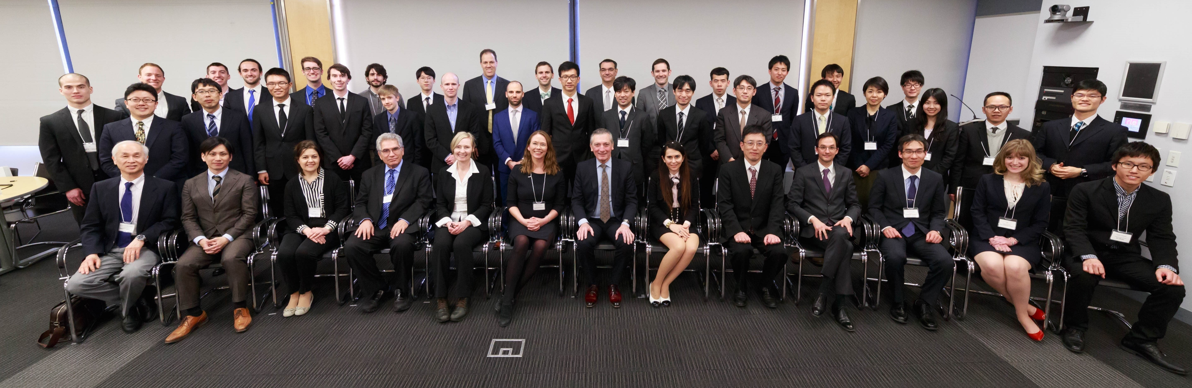
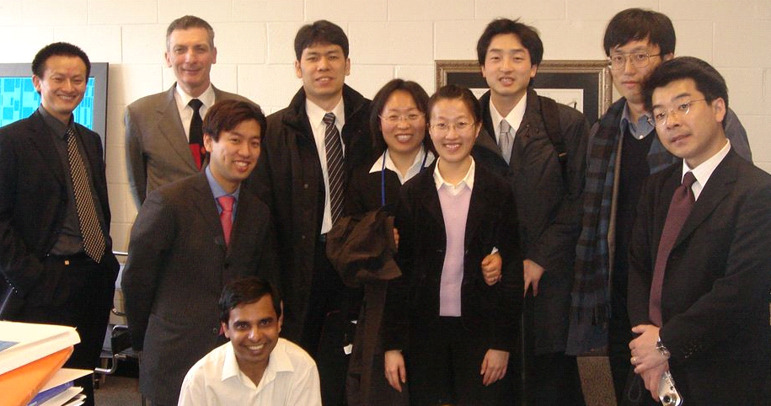
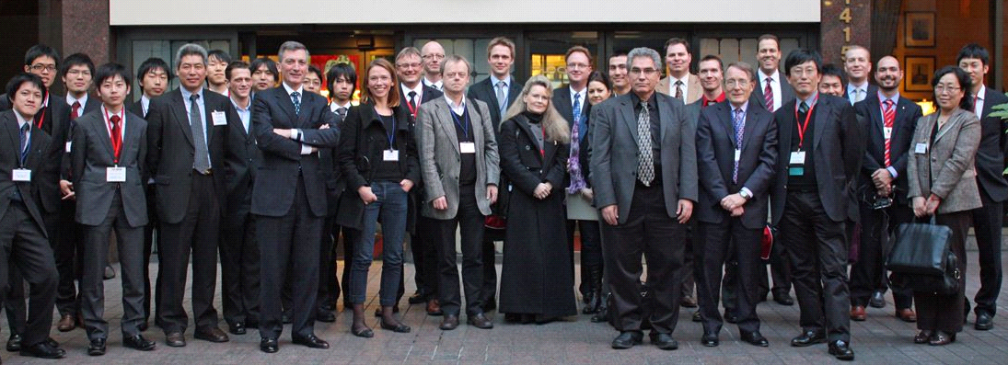
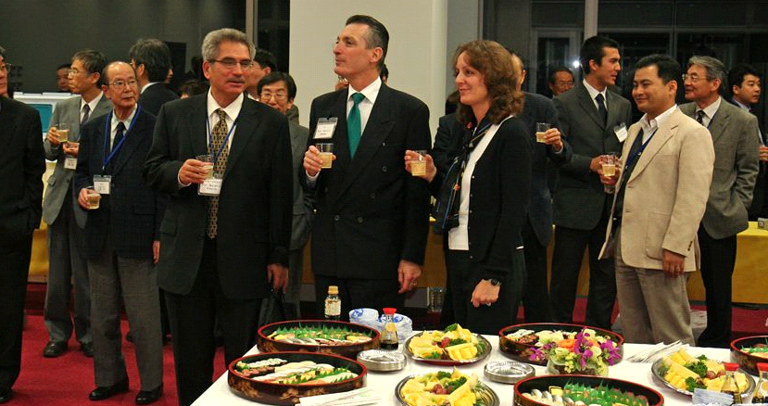
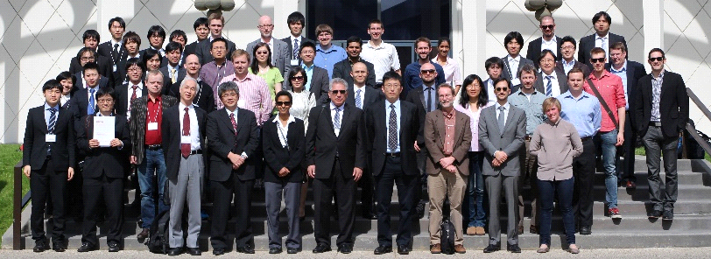
RMW13 in 2018 at MIT
RMW5 in 2010 at Seattle
RMW9 in 2014 at CALTECH
RMW1 in 2006 at MIT
RMW2 in 2006 at IIS
List of Participants
A. Semih Sunkar | Vice President | Nippon PGM America Inc.
Adam C. Powell, IV | Associate Professor | Worcester Polytechnic Institute
Aditya Moudgal  Akihiro Yoshimura | Graduate Student  Assistant Professor | Worcester Polytechnic Institute  Chiba University
Antoine Allanore | Associate Professor | MIT
Bingyu Lu | Graduate Student | UCSD
Caspar R. Stinn | Graduate Student | MIT
Christian Faria | Graduate Student | Worcester Polytechnic Institute
Donald R. Sadoway | Professor | MIT
Egil Skybakmoen | Research Manager | SINTEF
Espen Sandnes | Associate Professor | NTNU
Geir Martin Haarberg | Professor | NTNU
Gen Kamimura | Graduated student (PhD course) | The University of Tokyo
Gisele Azimi | Associate Professor | University of Toronto
Gøril Jahrsengene | Researcher | SINTEF
Gudrun Saevarsdottir | Associate Professor | Reykjavik University
Guillaume Lambotte | R&D Director | Boston Metal
Hojong Kim | Assistant Professor | Penn State
Hongmin Zhu | Professor | Tohoku University
Ji Zhao | Research Scientist | MIT
Jonathan Paras | Graduate Student | MIT
Jonghyun Han | Ph.D. Student | IIS, The University of Tokyo
Karen Sende Osen | Senior Research Scientist | SINTEF
Katie Daehn | Postdoctoral Associate | MIT
Kazuki Morita | Professor | The University of Tokyo
Luis Bracamonte  Mai Tanaka  Mary Elizabeth Wagner | PhD Student  Administrative Staff  PhD Candidate | NTNU  IIS, The University of Tokyo  MIT
Masatoshi Ueno | Managing Director | Komatsu, Ltd
Matt Mayer | PhD Student | UCSD
Michelle Chao | VP of Engineering | Phoenix Tailings Inc
List of Participants
Mike Martin |  | VP of Operations |  | Phoenix Tailings Inc
Omar Awayssa |  | PhD fellow |  | NTNU
Rebecca Miller
Shiori Suzuki |  | Administrative Staff |  | IIS, The University of Tokyo
Shunsuke Yagi |  | Associate Professor |  | IIS, The University of Tokyo
Takanari Ouchi |  | Research Associate |  | IIS, The University of Tokyo
Takara Tanaka |  | Graduate Student |  | IIS, The University of Tokyo
Teppei Suzuki |  | Graduate Student |  | MIT
Thomas Villalon |  | CTO |  | Phoenix Tailings Inc
Toru H. Okabe |  | Professor |  | IIS, The University of Tokyo
Toshiyuki Nohira |  | Professor |  | Kyoto University
William Judge |  | PhD Candidate |  | University of Toronto
Xin Lu |  | Assistant Professor |  | Tohoku University
Y. Shirley Meng |  | Professor |  | UCSD
Yonatan Afework Tesfahunegn |  | Assistant Professor |  | Reykjavik University
Yong Fan |  | Germany Humboldt PhD Fellow |  | TU Freiberg
Yongsheng Ren |  | Ph.D. Candidate |  | The University of Tokyo
Yasuhiro Fukunaka |  | Adjunct Researcher |  | Waseda University
Georges J. Kipouros |  | Adjunct Professor |  | University of Waterloo

