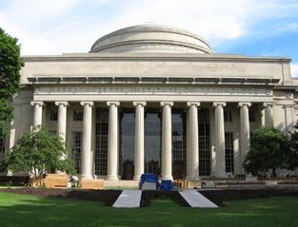
RMW19
(OKABE60)

The 19th Workshop on Reactive Metal Processing
March 20 (Fri.) – 21 (Sat.), 2026 @ MIT/Cambridge
(After TMS 2026, March 15 (Sun.) – 19 (Thu.), 2026 @ San Diego, California)

Organizers:
Donald R. Sadoway Massachusetts Institute of Technology
Toru H. Okabe Institute of Industrial Science (IIS),
The University of Tokyo
Antoine Allanore Massachusetts Institute of Technology
Shunsuke Yagi IIS, The University of Tokyo

Program Coordinators:
Takanari Ouchi IIS, The University of Tokyo
Gavin Anthony Winter Massachusetts Institute of Technology
Isaac Oda-Bayliss IIS, The University of Tokyo
Nathan Daniel Bradshaw Massachusetts Institute of Technology
Thananun Rattanamaneejarat IIS, The University of Tokyo

Sponsors
- The Rare Metal Research Workshop, one of the Special Research Groups organized by the Foundation for the Promotion of Industrial Science (FPIS)
- (RC-40: directed by Prof. T. H. Okabe, RC-104: directed by Prof. S. Yagi)
- Research Center for Sustainable Material Energy Integration (SUSMAT)
- Institute of Industrial Science, The University of Tokyo (IIS UTokyo SYMPOSIUM No.123)
http://www.okabe.iis.u-tokyo.ac.jp/core-to-core/rmw

The 19th Workshop on Reactive Metal Processing
(IIS UTokyo SYMPOSIUM No.123)
March 20 (Fri.) – March 21 (Sat.), 2026, MIT, Cambridge, MA

Time:
- 1st day: on March 20 (10:00 – 17:00 and Banquet at 18:30)
- 2nd day: on March 21 (10:00 – 14:00)
Refreshments will be served around 9:00 AM on both days.
Venue:
- Haus Allen Room (MIT)
- Boston Marriott Cambridge
Registration Fee:
$300 / person

Organizers:
Prof. Donald R. Sadoway Massachusetts Institute of Technology
Prof. Toru H. Okabe IIS, The University of Tokyo
Prof. Antoine Allanore Massachusetts Institute of Technology
Prof. Shunsuke Yagi IIS, The University of Tokyo
Program Coordinators:
Takanari Ouchi IIS, The University of Tokyo
Gavin Anthony Winter Massachusetts Institute of Technology
Isaac Oda-Bayliss IIS, The University of Tokyo
Nathan Daniel Bradshaw Massachusetts Institute of Technology
Thananun Rattanamaneejarat IIS, The University of Tokyo
Sponsors:
- The Rare Metal Research Workshop, one of the Special Research Groups
organized by the Foundation for the Promotion of Industrial Science (FPIS)
(RC-40: directed by Prof. T. H. Okabe, RC-104: directed by Prof. S. Yagi)
- Integrated Research Center for Sustainable Energy and Materials (SUSMAT)
- Institute of Industrial Science, The University of Tokyo (IIS UTokyo SYMPOSIUM No.123)
Contact:
Thananun Rattanamaneejarat, IIS, The University of Tokyo
E-mail: traa@g.ecc.u-tokyo.ac.jp

Workshop Program
Day 1
Morning, March 20 (Friday), 2026 @ Haus Allen Room (MIT)
19:00 – 10:00 Coffee & Breakfast Service
10:00 – 10:10 Opening Remarks
Prof. Emeritus Donald R. Sadoway
Massachusetts Institute of Technology

Session Chair: Prof. Shunsuke Yagi
10:10 – 11:00 TBD
Toru H. Okabe
IIS, The University of Tokyo

11:00 – 11:20 Break

Session Chair: Prof. Antoine Allanore
11:20 – 11:50 TBD
Gavin Winter
Massachusetts Institute of Technology

11:50 – 13:00 Lunch

Session Chair: Prof. Adam C. Powell, IV
13:00 – 13:30 Development of extraction techniques for platinum group metals: alloying and chlorination pretreatments
Yuki Taninouchi
Kyushu University
13:30 – 14:00 LiS₂ Production from Various Li Feedstocks using Chemical Potential Diagrams toward Next-Generation Rechargeable Batteries
Jungshin Kang
Seoul National University

14:00 – 14:20 Photo & Break

Session Chair: Dr. Taka Narumi
14:20 – 15:20 3-min Short Presentation by Poster Presenters
15:20 – 16:20 Poster Session at the Haus Room and Allen Room at Building 36

18:00 – Reception @ Boston Marriott Cambridge
18:30 – Banquet @ Boston Marriott Cambridge

Day 2
Morning, March 21 (Saturday), 2026 @ Haus Allen Room (MIT)
9:00 – 10:00 Coffee & Breakfast Service
10:00 – 10:10 Opening Remarks
Prof. Antoine Allanore
Massachusetts Institute of Technology

Session Chair: Prof. Ragnhild Elizabeth Aune
10:10 – 10:40 Density and Surface Tension Measurement for Molten TiO₂, ZrO₂, HfO₂ using Pendant Drop Method
Osamu Takeda
Tohoku University

10:40 – 11:00 Break

Session Chair: Prof. Yuki Taninouchi
11:00 – 11:30 Additive Manufacturing of Niobium-Based Refractory Alloys: Powder Development and Processing of C-103, FS-85 and Cb-752
Katsuhiro Nose
Taniobis
11:30 – 12:00 Magnesium Production in an Aluminum Smelter
Adam C. Powell, IV
Worcester Polytechnic Institute

12:00 – 12:10 Information for the Next RMW
Shunsuke Yagi
IIS, The University of Tokyo
12:10 – 12:20 Closing Remarks
Toru H. Okabe
IIS, The University of Tokyo

12:20 – 13:30 Lunch

13:30 – Laboratory Tour

List of Poster Presenters
- Electrochemical characterization of molten oxide melts for manganese deposition
Braulio Beltrán-Pitarch¹,
¹Norwegian University of Science and Technology (NTNU)
- ACV Measurements in Molten Systems
Nathan Daniel Bradshaw¹,
¹Massachusetts Institute of Technology
- Ammonia Synthesis in Molten Chloride Salt
Xiaofei Guan¹,
¹ShanghaiTech University
- Molten Oxide Electrolysis for Manganese Production - The Effect of Iron
Gøril Jahrsengene¹,
¹SINTEF
- Electrochemical behavior of oxygen-evolving anodes in LiCl-Li₂O electrolyte
Hojong Kim¹,
¹Pennsylvania State University
- Modeling and simulation of a flow electrolysis process for sustainable Iron production
Omid Mahdavi¹,
¹Worcester Polytechnic Institute
- Thermophysical Properties of Molten Iron Alloys
Lucas Marden¹,
¹Massachusetts Institute of Technology
- Recent study on the recycling process of zinc from EAF dust through selective chlorination, purification, and molten salt electrolysis
Hiroyuki Matsuura¹,
¹The University of Tokyo
- TBD
Eve Meltzer¹,
¹Massachusetts Institute of Technology
- The Sulfidation of Iron Oxides
Matthew Michalek¹,
¹Massachusetts Institute of Technology
- Kinetic Investigations of Ferronickel Dissolution and Sulfidation for Carbon-Free Nickel Separation
Hrishikesh Nirgude¹,
¹Worcester Polytechnic Institute
- Redox of Cathode Active Material ZnMnO₃ and Electrolyte for Magnesium Batteries
Ryotaro Otake¹,
¹Institute of Industrial Science, The University of Tokyo
- Development of SO₂ Depolarized Electrolysis Systems for Hydrogen Production
Isaac Oda-Bayliss¹,
¹Institute of Industrial Science, The University of Tokyo
- Magnesium-Air Battery for Maritime Shipping
Peter Poulos¹,
¹—
- Antimony-Doped alpha-MnO₂ for Magnesium Battery Positive Electrode Active Materials
Thananun Rattanamaneejarat¹,
¹Institute of Industrial Science, The University of Tokyo
- Assessment of End-of-Life Solar Panel Glass for MoE of Si Electrolytes
M. Akbar Rhamdhani¹,
¹Swinburne University of Technology
- Rapid production of pure titanium utilizing rare-earth oxyfluoride formation
Kaneko Takumi¹,
¹Institute of Industrial Science, The University of Tokyo
- Electrowinning of Ferromanganese by Molten Oxide Electrolysis (MOE) with Consumable Iron Cathode
Håkon Ulvik¹,
¹Norwegian University of Science and Technology (NTNU)
- Calcium phosphate in high temperature sulfidation environment
Ava Waitz¹,
¹Massachusetts Institute of Technology
- Study on Ag/Cu Composite Catalysts for Multicarbon Product Generation via Electrochemical CO₂ Reduction
Chubo Wang¹,
¹Institute of Industrial Science, The University of Tokyo
- CO2-to-Formate Electrochemical Reduction Promoted by Defect-Driven Reconstruction of Bismuth Nanoflower Catalysts
Jiaying Yan¹,
¹Institute of Industrial Science, The University of Tokyo

History of RMW
2006 The 1st Workshop on Reactive Metal Processing (RMW1)
March 17 (Fri.) - March 19 (Sat.), Cambridge, MIT
2006 The 2nd Workshop on Reactive Metal Processing (RMW2)
November 16 (Thurs.) - November 17 (Fri.), Tokyo, The University of Tokyo
2007 The 3rd Workshop on Reactive Metal Processing (RMW3)
March 2 (Fri.) - March 3 (Sat.), Cambridge, MIT
2008 The 4th Workshop on Reactive Metal Processing (RMW4)
March 14 (Fri.) - March 15 (Sat.), Cambridge, MIT
2010 The 5th Workshop on Reactive Metal Processing (RMW5)
February 18 (Thurs.) - February 19 (Fri.), Seattle, Red Lion Hotel on 5th Avenue
2011 The 6th Workshop on Reactive Metal Processing (RMW6)
March 4 (Fri.) - March 5 (Sat.), Pasadena, Caltech
2012 The 7th Workshop on Reactive Metal Processing (RMW7)
March 16 (Fri.) - March 17 (Sat.), Cambridge, MIT
2013 The 8th Workshop on Reactive Metal Processing (RMW8)
March 8 (Fri.) - March 9 (Sat.), Cambridge, MIT
2014 The 9th Workshop on Reactive Metal Processing (RMW9)
February 21 (Fri.) - February 22 (Sat.), Pasadena, Caltech
2015 The 10th Workshop on Reactive Metal Processing (RMW10)
March 20 (Fri.) - March 21 (Sat.), Cambridge, MIT
2016 The 11th Workshop on Reactive Metal Processing (RMW11)
February 19 (Fri.) - February 20 (Sat.), Cambridge, MIT
2017 The 12th Workshop on Reactive Metal Processing (RMW12)
March 3 (Fri.) - March 4 (Sat.), Cambridge, MIT
2018 The 13th Workshop on Reactive Metal Processing (RMW13)
March 16 (Fri.) - March 17 (Sat.), Cambridge, MIT
2019 The 14th Workshop on Reactive Metal Processing (RMW14)
March 15 (Fri.) - March 16 (Sat.), Cambridge, MIT
2020 The 15th Workshop on Reactive Metal Processing (RMW15)
February 28 (Fri.) - February 29 (Sat.), San Diego, UC San Diego
2023 The 16th Workshop on Reactive Metal Processing (RMW16)
March 24 (Fri.) - March 25 (Sat.), Cambridge, MIT
2024 The 17th Workshop on Reactive Metal Processing (RMW17)
March 24 (Fri.) - March 25 (Sat.), Cambridge, MIT
2025 The 18th Workshop on Reactive Metal Processing (RMW18)
March 28 (Fri.) - March 29 (Sat.), Cambridge, MIT
RMW1 in 2006 at MIT RMW2 in 2006 at IIS
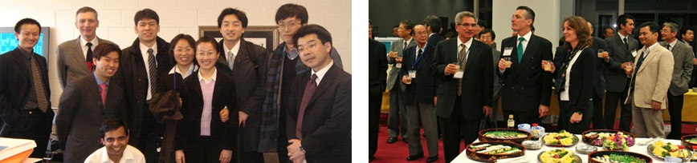
RMW5 in 2010 at Seattle RMW17 in 2024 at MIT
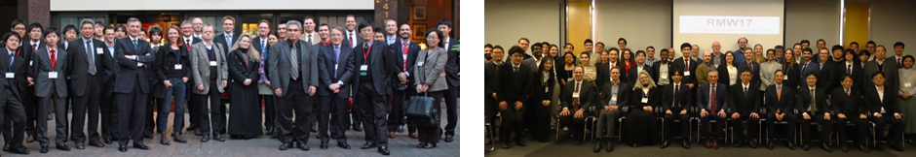
Venue Details
Workshop:
Haus Allen Room
Building 36, Room 462 (4th floor)
50 Vassar St, Cambridge, MA 02139
Interactive Campus Map available at: http://whereis.mit.edu/

Banquet:
Boston Marriott Cambridge
50 Broadway, Cambridge, MA 02142, United States
