RMW7
The 7th Workshop on Reactive Metal Processing
March 16(Fri) - March 17(Sat), 2012 @ MIT
Cambridge, MA

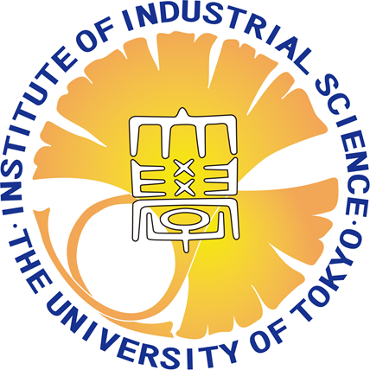
Organizers
Donald R. Sadoway, Massachusetts Institute of Technology
Toru H. Okabe, IIS, the University of Tokyo

Program coordinators
Katsuhiro Nose, IIS, the University of Tokyo
Takashi Nagai, IIS, the University of Tokyo

http://www.okabe.iis.u-tokyo.ac.jp/core-to-core/rmw/

Time:
- 1st day: on Mar 16 Lecture & Banquet
- 2nd day: on Mar 17 Lecture
Venue:
- Grier Room
EG&G Education Center, Building No.34, MIT,
77 Massachusetts Avenue, Cambridge, MA 02139
Registration Fee:
To be announced.
Contact address:
Katsuhiro Nose, Institute of Industrial Science, the University of Tokyo
E-mail: nose-k@iis.u-tokyo.ac.jp Phone: +81-3-5452-6820
http://www.okabe.iis.u-tokyo.ac.jp/core-to-core/rmw/
History of RMW

2006 The 1st Workshop on Reactive Metal Processing (RMW1)
March 17 (Fri.)- March 19 (Sat.), Cambridge, MIT
2006 The 2nd Workshop on Reactive Metal Processing (RMW2)
November 16 (Thurs.)- November 17 (Fri.), Tokyo, The University of Tokyo
2007 The 3rd Workshop on Reactive Metal Processing (RMW3)
March 2 (Fri.)- March 3 (Sat.), Cambridge, MIT
2008 The 4th Workshop on Reactive Metal Processing (RMW4)
March 14 (Fri.)- March 15 (Sat.), Cambridge, MIT
2010 The 5th Workshop on Reactive Metal Processing (RMW5)
February 18 (Thurs.)- February 19 (Fri.), Seattle, Red Lion Hotel on 5th Avenue
2011 The 6th Workshop on Reactive Metal Processing (RMW6)
March 4 (Fri.)- March 5 (Sat.), Pasadena, Caltech

