RMW9
The 9th Workshop on Reactive Metal Processing
February 21 (Fri.) - February 22 (Sat.), 2014
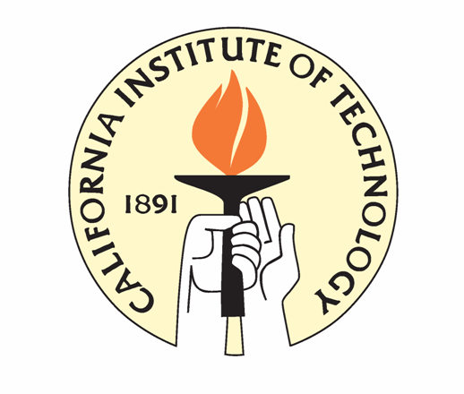
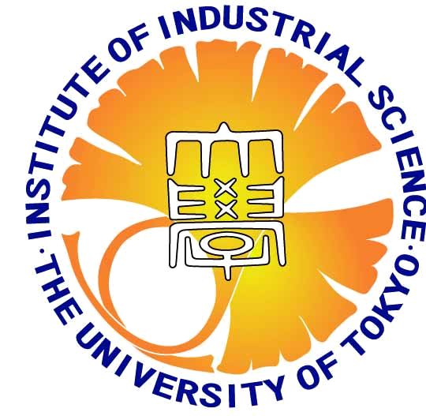
@ Caltech, Pasadena
Organizers:
Prof. Donald R. Sadoway, Massachusetts Institute of Technology
Prof. Toru H. Okabe, IIS, the University of Tokyo
Prof. Sossina M. Haile, California Institute of Technology
Prof. Tetsuya Uda, Kyoto University

Date: February 21 (Fri.) Invited lecture, Poster presentation, & Banquet
February 22 (Sat.) Invited lecture & Lab. Tour
Venue: California Institute of Technology
Fee: 200USD
Web site: http://www.okabe.iis.u-tokyo.ac.jp/core-to-core/rmw/
Registration: Yu-ki Taninouchi, The University of Tokyo
E-mail: taninou@iis.u-tokyo.ac.jp
Please send me following information by e-mail.
1) Name
2) Affiliation
3) Position
4) E-mail address
5) Poster presentation (YES or NO)
6) Poster title
7) Courtesy bus from San Diego to Pasadena on Feb. 20 (YES or NO)
[We recommend use of courtesy bus for attendees of TMS2014.]
Registration deadline:
November 20 (Wed.)
History of RMW

2006 The 1st Workshop on Reactive Metal Processing (RMW1)
March 17 (Fri.)- March 19 (Sat.), Cambridge, MIT
2006 The 2nd Workshop on Reactive Metal Processing (RMW2)
November 16 (Thurs.)- November 17 (Fri.), Tokyo, The University of Tokyo
2007 The 3rd Workshop on Reactive Metal Processing (RMW3)
March 2 (Fri.)- March 3 (Sat.), Cambridge, MIT
2008 The 4th Workshop on Reactive Metal Processing (RMW4)
March 14 (Fri.)- March 15 (Sat.), Cambridge, MIT
2010 The 5th Workshop on Reactive Metal Processing (RMW5)
February 18 (Thurs.)- February 19 (Fri.), Seattle, Red Lion Hotel on 5th Avenue
2011 The 6th Workshop on Reactive Metal Processing (RMW6)
March 4 (Fri.)- March 5 (Sat.), Pasadena, Caltech
2012 The 7th Workshop on Reactive Metal Processing (RMW7)
March 16 (Fri.)- March 17 (Sat.), Cambridge, MIT
2013 The 8th Workshop on Reactive Metal Processing (RMW8)
March 8 (Fri.)- March 9 (Sat.), Cambridge, MIT

