講演会のお知らせ

Exploration of Structure-Thermodynamic Correlations in Oxides
Using
High-Precision Solid-State
Electrochemical Techniques

Professor K. T. Jacob

Indian Institute of Science, Bangalore

９月１８日（火）３：００～

東京大学生産技術研究所 セミナー室（Ｃｅ６０２号室）

連絡先：
岡部 徹
Tel. 03-5452-6312 （直通）
Tel. 03-5452-6314 （岡部研究室）
Fax. 03-5452-6313 （研究室）
e-mail. okabe@iis.u-tokyo.ac.jp
東京大学生産技術研究所への案内図

住所：〒153-8505目黒区駒場４－６－１
京王井の頭線「駒場東大前駅」もしくは地下鉄千代田線「代々木上原駅」から徒歩約１５分：
地図はhttp://www.iis.u-tokyo.ac.jp/map/index.html参照

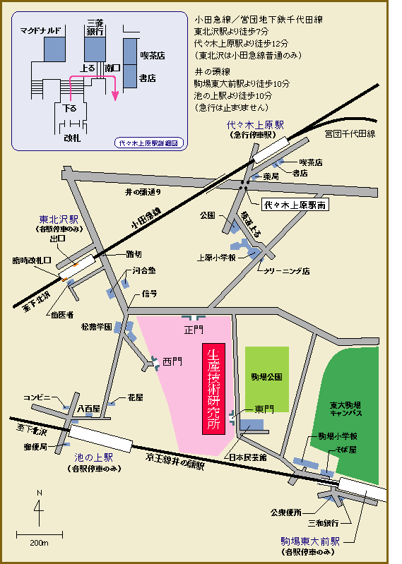
岡部研究室
生産技術研究所Ｆ棟３Ｆ Fw302号室
講演会会場Ce602号室

About the Speaker

Professor K. T. Jacob

Department of Metallurgy, Indian Institute of Science, Bangalore, India

Professor K. T. Jacob was educated at the Indian Institute of Science and Imperial College of Science and Technology, London. His Ph.D. thesis under Professors F.D. Richardson and J.H.E. Jeffes was on the behavior of oxygen in liquid metallic solutions. From 1970 to 1983 he held several academic positions at the University of Toronto. Back to India, he was first Chairman of the Department of Metallurgy and subsequently of the Materials Research Center. He is the current Chair of the Materials Program Advisory Committee of the Department of Science and Technology, Government of India. He has held visiting professorships at the Pennsylvania State University, Royal Institute of Technology, Stockholm, Max-Planck Institute for Metallforschung and Tohoku University. He functioned as a consultant to Lawrence Berkeley Laboratory, International Nickel Company Ltd., McDonnel Douglas Astronautics Company, Hewlett-Packard and NASA Ames Research Center.

Professor K. T. Jacob, through his creative and leading research during the past 30 years, has made extensive fundamental contributions to the fields of extractive metallurgy, chemical processing of ceramics and materials chemistry. In particular, his contributions to thermodynamics of metals and their compounds, modelling of high temperature systems and processes, and solid-state sensors for process control and optimisation have provided strong leadership and guided the evolution of research in these areas. Development of the concepts of auxiliary electrodes, non-isothermal probes, temperature compensated reference electrodes, composite and composition-gradient solid electrolytes are among the pioneering contributions of Professor Jacob to the development of high-temperature solid-state chemical sensors. His predictive models on the behaviour of non-metallic solutes in liquid alloys and spinel solid solutions are extensively used. Thermodynamic and phase-equilibrium measurements by his group have provided over the years consistently reliable high quality data on systems of crucial importance to metallurgy and ceramics.

Professor K. T. Jacob serves on the editorial boards of ten journals. He is the author/co-author of more than 330 scientific papers in reputed international journals, covering both theoretical and experimental studies. He has delivered numerous invited lectures worldwide and has been honoured by several awards. He is a fellow of all the science and engineering academies in India.
Exploration of Structure-Thermodynamic Correlations in Oxides Using
High-Precision Solid-State
Electrochemical Techniques

Professor K. T. Jacob

Indian Institute of Science, Bangalore

Abstract

Successful exploration of the correlation between crystallographic and electronic structure on the one hand and thermodynamic properties requires high quality data. Some of the critical factors in the design of solid-state electrochemical cells for thermodynamic measurements at high temperatures are reviewed. New advanced versions of the cell that provide higher accuracy are presented. The results for Cu₂Ln₂O₅ compounds (Ln = lanthanide element) show that thermodynamic properties and “global instability index” assessed from structural data follow similar trends. Studies on M-Pb-O systems (M = Ca, Sr, Ba) show the influence of “tolerance factor” on thermodynamic stability and the importance of acid-base interactions in stabilizing higher valence states of lead in ternary and higher order oxides. The solid-state cell can also be crafted for the exploration of thermodynamic properties of nanocrystalline oxides and measurement of surface properties of oxides. The results show the thermodynamic basis for size-induced structural transformations.

