平成１３年９月１０日
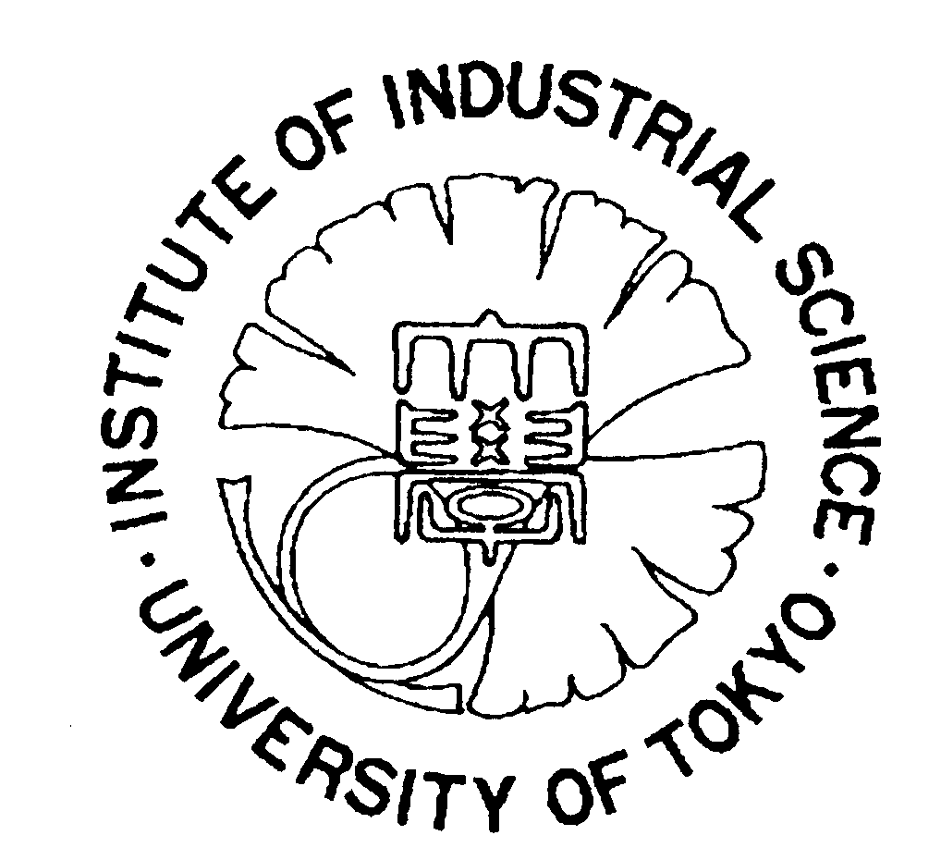

フレイ教授講演会および新研究所見学のお知らせ

関係者各位

下記のとおり講演会および研究室見学会を開催いたします。参加希望者は、9月中に東大・生産研の斎藤（前田研秘書）に連絡ください。会場の都合上、先着順に参加者を制限させていただくこともございますので、どうかご了承ください。
岡部 徹

記
研究所・研究室見学会

日時： １０月９日（火）１：３０～
集合場所： 東京大学生産技術研究所、Ｆ号棟 Ｆｗ３０２号室 （添付資料参照）
見学場所： 生産技術研究所の材料系共通設備全般および岡部研究室

講演会

日時： １０月９日（火）３：００～
会場： 東京大学生産技術研究所 セミナー室（Ｃｅ６０２号室）
（参加人数により第３会議室（プレハブ棟２Ｆ）に会場を変更する可能性があります。添付資料参照）
講演者： ケンブリッジ大学 Ｄ．フレイ教授
演題： 電解脱酸法を用いたチタン酸化物および他の金属酸化物の還元
（社）日本チタン協会、東京大学、京都大学 共催

参加申し込み

お名前、ご所属に加え、見学会参加の希望についても以下の申し込み先にご連絡ください。（申し込みは、メールもしくはファックスが望ましいですが、電話や郵送でも構いません。）

参加申し込み先：
齋藤加余子（東京大学生産技術研究所 前田教授秘書）
〒153－8505 目黒区駒場4－6－1 Fe-212号室
Tel: 03-5452－6298 Fax: 03-5452－6299
e-mail: kayoko@iis.u-tokyo.ac.jp
講演会および研究室見学のお知らせ

電解脱酸法を用いた
チタン酸化物および他の金属酸化物の還元

ケンブリッジ大学 Ｄ．フレイ教授

１０月９日（火）３：００～

東京大学生産技術研究所 セミナー室（Ｃｅ６０２号室）※

（社）日本チタン協会、東京大学、京都大学 共催

※ 参加人数により第３会議室（プレハブ棟２Ｆ）に会場を変更する可能性があります。

★ 講演会に先立って当日１：３０より研究室見学会を行います。希望者はお手数ですが、事前に岡部までご連絡ください。（集合場所：Ｆｗ３０２号室）
見学場所：本年四月開所した生産技術研究所の材料系共通設備および岡部研究室

申し込み先： 連絡先：
齋藤加余子（前田教授秘書） 岡部 徹
Tel. 03-5452-6298 （直通） Tel. 03-5452-6312 （直通）
Fax. 03-5452-6299 Tel. 03-5452-6314 （岡部研究室）
e-mail. kayoko@iis.u-tokyo.ac.jp Fax. 03-5452-6313 （研究室）
e-mail. okabe@iis.u-tokyo.ac.jp
東京大学生産技術研究所への案内図

住所：〒153-8505目黒区駒場４－６－１
京王井の頭線「駒場東大前駅」もしくは地下鉄千代田線「代々木上原駅」から徒歩約１５分：
地図はhttp://www.iis.u-tokyo.ac.jp/map/index.html参照

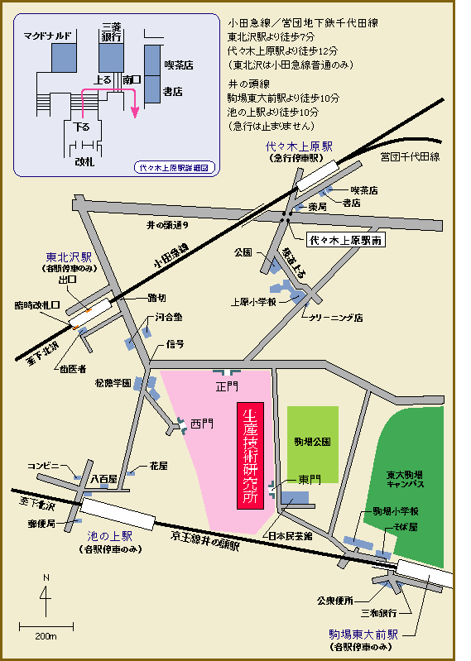
見学会集合場所Fw302号室
岡部研
講演会会場Ce602号室
参加者が多い場合の講演会会場：
プレハブ棟２Ｆ 第３会議室

The use of electrodeoxidation to reduce titanium dioxide and other metal oxides

Derek Fray
Department of Materials Science and Metallurgy
University of Cambridge
Cambridge CB2 3QZ

Titanium is usually extracted by the Kroll process in which titanium tetrachloride is reduced by magnesium to form titanium sponge and magnesium chloride. This is an expensive and time consuming process which makes titanium a costly metal and although titanium and its alloys have excellent properties, high strength, low density and very good corrosion resistance, its use is restricted by its high cost. Electrodeoxidation is a very simple technique where the oxide to be reduced is made the cathode in a fused salt of an alkaline earth chloride. By applying a voltage, below the decomposition potential of the salt, it has been found that the cathodic reaction is the ionization of oxygen from the oxide to leave a pure metal. In the laboratory, this technique has been applied to a large number of metal oxides, including titanium dioxide. Another interesting observation is that when a mixture of oxides is used as the cathode, the metals form an alloy of uniform composition. This could be a considerable advantage for those alloys that are difficult to prepare using conventional technology.
フレイ博士の経歴紹介：

Professor Derek Fray BSc(Eng), MA, PhD, ARSM, DIC, FREng,
FIMM, MIM, CEng.

In 1958, Derek Fray won a scholarship to Imperial College, London University to Study Metallurgy. After graduating in 1961, with first-class honours, he undertook research on the properties of fused salts in the Nuffield Research Group, Imperial College. In 1965, he was awarded the PhD. Degree and the Matthey Prize.

Between 1965 and 1968, he was an Assistant Professor of Metallurgy at the Massachusetts Institute of Technology teaching thermodynamics, heat and mass transfer and the chemistry of materials. His research interests were concerned with fused salts and the thermodynamics of steelmaking reactions.

In 1968, he returned to the U.K. to work in the research department of the Imperial smelting Corporation Ltd. As a group leader responsible for projects concerned with fused salt electrolysis, the treatment of dilute solutions, processing of zinc dusts and residues and the refining of aluminium m containing alloys.

In 1971, he was appointed University Lecturer in Materials Science and Metallurgy at the University of Cambridge teaching thermodynamics, extraction metallurgy and rate processes. He was a Fellow of Fitzwilliam College, Bursar of the College and Director of Studies in Materials Science and Metallurgy.

In 1991, he joined Leeds University as Professor of Mineral Engineering and became Head of the Department of Mining and Mineral Engineering in October 1991. His research interests included electrowinning form dilute solutions, properties of the electrolytes for the extraction of lithium, the treatment of electric arc furnace dust, the recycling of secondary materials, the control of oxide phases for the prevention of high temperature oxidation and the development of solid electrolyte sensors for the refining and on-line analysis of metallurgical phases and gases.

On 1 February 1996, he became Professor of materials chemistry, University of Cambridge and Professorial Fellow, Fitzwilliam College, and in 2001 he became Head of Department of Materials Science and Metallurgy, University of Cambridge.

Derek Fray is a Fellow of the Institution of Mining and Metallurgy and a member of the Materials Society and the American Institute of Metallurgical engineers. He has published over 250 articles on materials processing and one book and is cited as the inventor on over 120 published patents. Twelve projects are now under active industrial development both in the U.K. an Europe, Australia and the United States. In 1980, he was awarded the AIME Extractive Metallurgy Technology Award and in 1981, a Nuffield- NSERC Visiting Lectureship at various institutions in Canada, and the Sir George Beilby Medal by the Royal Society of Chemistry for the application of science. In 1987, he was awarded the Kroll medal by the Institute of Metals and, in 1989, he was elected to the Fellowship of the Royal Academy of Engineering. In 1991, he was awarded the John Phillips Medal by the Mineral Industry Research Organisation. In 1995, he was made an Honorary Professor at the University of Science and Technology, Bejing, China and in 1996 was appointed as a Visiting Professor, University of Leeds. In 2000, he was chosen to receive the Minerals, Metals & Materials Society’s 2000 extraction and Processing Distinguished Lecture Award and, in 2001, he was awarded the Billiton Medal by the Institution of Mining and Meatallurgy.

He has consulted widely on the use of solid electrolyte sensors, applications of fused salts, electrowinning from aqueous solutions and the recycling of metals. He is a founder director of Ion Science Ltd., Ion Science Messtechnik Gmbh., Environmental Monitoring and control Ltd., Cambridge Advanced Materials Ltd. and British Titanium plc. All these companies are exploiting technology developed by Derek Fray.

